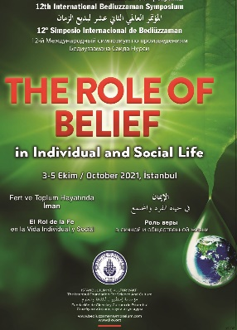  BELIEF AND HAPPINESS IN BOTH WORLDS: BUILDING A PROSPEROUS INDIVIDUAL | Belief and happiness in both worlds: Building a Prosperous Individual  Dr. Nisar Ahmad  8-29-2021

THE ROLE OF BELIEF IN INDIVIDUAL AND SOCIAL LIFE
(The Role of belief in individual life)
Belief and happiness in both worlds: Building a Prosperous Individual
With the rise of the 21st century, the advancement in science and technology has changed the living style of individuals across the globe. Surprisingly, this change has dispersed both human values and spiritual belief system of man rigorously. The substance of faith, in terms of underlying spirit, has become delinked from forms and rituals. Disbelieving, as a prime factor, has raised lots of problems, disappointments, crises, external quietness, and have also snatched the real charm and happiness from humans. Belief is the most effective source that filters the materialism, mental disorders, and external quietness, and various other troubling illnesses of life from such individuals. It is the power of belief that keeps us calm and stable humans even at the time of critical challenges and severe crises. This research empowers the human self and belief with empirical, philosophical, and modern thoughts of Said Nursi to combat materialism, secularism, and other similar approaches by analyzing the data theoretically. With the help of the Risal-i-Nur study, this research describes the importance and significance of belief in individuals’ life that actually brings prosperity and happiness in both worlds. Additionally, a short survey of the impacts of faith and spirituality will also be presented to highlight the importance and development of faith for sustainability and well-being in human life. The study comprising Nursi’s thoughts also aims to empower humans to counter the contemporary challenges. The major objective of this study is to promote the Islamic perspectives of a balanced life that deals with the real happiness of an individual’s body, mind, heart, and soul in both worlds.
Key Words: Belief, challenges, materialism, Balanced life, Nursi Studies, Happiness

1) Introduction:
With the rise of the 21st Century, we have reached an age where the advancement of technology has put human life in a dynamic new sphere of rapid change. We see yesterday’s fiction has now become today’s reality. Undoubtedly, technology has made human life far convenient and luxurious than that of the previous ages, and according to Said Nursi, scientific knowledge is the bounty of God and man should use the modern technology positively rather he suffers. And the light of conscience is what we receive from science and religion, but if it is lacking, skepticism will prevail and the lack of scientific advancement brings fanaticism. Science and technology are more than just we think-tools to get things done in a magical super advanced way. The holy Quran deliberately emphasizes on innovation and scientific knowledge for the best of humans. Numerous verses of it call the people to search and prove the things to empower your faith. “Behold in the creation of the heavens and the earth, and the alternation of night and day, there are indeed signs for men of understanding. He attempted to reconcile religion and science. He said, “The light of con-science is [the result of] the sciences of religion, and the light of the mind is [the resultof] the natural sciences. By bringing these together, the truth will come out as a result. The lack of the modern sciences causes fanaticism, while the lack of religious sciencescauses skepticism”
Despite the advancement in technology that has brought enormous benefits to humans and has made their living convenient incredibly; it has also affected humans’ behavior at a dangerous level. This rampantly materialistic change leaves into secularistic and humanistic states with the denial of spiritualism or monotheism.
This social change eliminates “humanity” from the human’s life because of neuroticism-a result of the dangers of materialism. Moreover, with this rapid advancement in technology, impacts of it, now, are not the separate entities to be dealt with technological forms of life but rather an integral aspect of human daily affairs. There is an exponential rate of studying human behavioral change with the rapid growth and advancement in technologies in the last 20 to 25 years . Through this wider studied research, we might be able to compensate for this imbalanced behavior among the human’s basic faculties. The emerging trend to counter such intrinsic problems of human behaviors has become the biggest question for contemporary social scientists in general and for Muslim researchers in particular to counter such challenges of the 21st century.
Individuals, with materialistic minds, are unhappy, dissatisfied and, are unfocused on what they have, rather they feel desperate with what they do not have in their lives. Most often, they, do not think about the positive aspects of life because they are mesmerized by the glitter and glossiness of the world. At the same time, it has left the people in a significantly drastic change of social, physical, intellectual, and spiritual inactiveness. The disruptive features of modernity and modernization have brought: anxiety, behavioral change, juvenile delinquency, violence, mental illness, and various conflicts of social and religious nature. It has pushed humans back into a digital cave where the effects of these negative emotions have stagnated their mental, physical, and spiritual growths. Individual behaviors, habits, perceptions, social relationships and constructionism, human moral entities are all wrapped up with this new sphere of advancement in technologies.
Studies, across the globe that analyze the impacts of materialism, have confirmed its negative impacts on social wellbeing , inner peace, and life satisfaction in human life. The study also found the association of materialism with envoy, and dissatisfaction in human life. Goldberg writes: young individuals are the easy-trapped people towards negative impulses when they are having materialistic views . It deals with an anti-social spectrum that results in conflicts and contradictions especially between husband and spouse and it leads the person to indulge in sexually promiscuous , shoplifting , and various other negative attitudes. People, with a higher level of materialistic values, are the individuals who are observed with a higher level of dissatisfaction unhappiness, and a lower standard of self-actualization.
Following impacts can be seen in an individual’s living who is burdened with materialism.
- Acquisition of wealth particularly material goods that produce discomfort, envy, lust, and idolatry.
- Accumulation that brings the love of money without considering the concept of right or wrong, jealously
- Self-interest that loads greed, denial of social wellbeing.
- Void of faith that results in despair and hopelessness, agnosticism that eventually pushes him back into atheism
It reflects that a materialistic person has a lower or poor well-being in life than that of the realistic individual. And to strive for such material goals means to compromise on emotional gratification, the realm of life, and facing the lowest level of satisfaction. In this context following two problems are identified.
2) Problems of the statement:
- Humans are increasingly falling prey to materialistic approaches which create inhuman values and imbalanced behavior that causes them to be deprived of a prosperous and eudemonic life.
- Since, this materialism has dropped the values of humanity increasingly, they need a leading pattern that directs happiness and wellbeing.
3) Research Questions:
This research significantly deals with the following major research questions to present valuable answers.
- How faith (& Spirituality) shape human personality and counter newfangled challenges of the century to build a prosperous and successful society?
- What is the systematic approach that Islam presents to attain a balanced life leading to prosperity, happiness, and real ecstasy in life as well as success in both the worlds?
- What scholarly approaches are presented in Risale-i Nur, to lead the individuals for a sustainable, and prosperous well-being in 21st century’s perspective by Bediuzzaman Said Nursi.
4) Responding to the above-raised questions and the Case of Said Nursi
To respond to such an alarming and critical situation, Ustad Bediuzzaman Said Nursi emerges with a highly significant and compatible role to counter such disruptive and increasingly prevailing challenges of materialism, ill-manners, secularism, domestic violence, and disbelieving that cause to lose human values.
Since he already had felt the stealthy effects of these challenges to Muslim civilization and culture which had threatened their faith and religiosity. So, he figured out the solution to these very serious problems particularly discernment of faith facing the Muslim community. He was well aware that Islam is not a passive responder to such challenges but rather a religion with “wisdom and excellent admonition.
He was well aware of the materialism that leads to atheism, far before today’s advancement in technology and its effect on faith and religious thoughts: I went to Ankara in 1922 and the people of faith were enjoying the victory against the Greek army, but among their views, I found the very decisive idea of atheism entering the minds and poisoning the hearts and I was afraid that this monster would attack the main principles of faith.Then the verse of the Quran helped me to write against the idea of irreligiosity: their messenger said, is there a doubt about God, the creator of the heavens and the earth?
He was adequately careful about the causes and particularly prevailing effects of materialism on Muslim society. “O you despondent and unrest soul which spreads and disperses unbelief and selfishness! Can a man who is enduring torments and is beset with horrendous disasters in both his soul and his inner-self and his head and his heart, be glad and satisfied through his body being in a shallow, misleading sparkle and riches? Would it be reasonable to say that he is happy? Do you not feel that a person who becomes disappointed and despaired at small matters and his expectation being extinguished concerning so fanciful goals and his being disillusioned at some immaterial business, such a man's sweet hope turned out to be intense for him? The world becomes a prison and bitter place for such a man?”
He seems to establish a dichotomy between the two cultures: first, that was inclined with materialism and the second one was rather progressive and got benefitted by applying the intellect with the inculcation of divine sources. But the alarming situation from the abandoned culture and the materialism which produces mental anxiety, dissatisfaction, and unhappiness was deliberately disregarded by him. He, not only identified such intellectual and spiritual challenges to Muslims, but rather marked them as diseases of both body and soul.
Following the views of said Nursi clearly depicts how he disregards this destructive materialism and how it affects individual’s wellbeing: "Is it possible to say about someone whose body is in false and fleeting heaven and whose emotions and soul are suffering the torments of Hell that he is satisfied and fully happy? Obviously, you have driven off track from the right direction of the miserable humankind along these lines. You have pushed mankind into the torments of Hell in a false paradise. [21]” He also demonstrates to combat the effects of these challenges with the light of empowered faith to attain real happiness, wellbeing, prosperity, and success in both of the worlds. He believed that it would only come into being when they have enriched themselves with Quran and particularly its faith-based lessons for which he served his entire life.
5) Bediuzzaman Said Nursi a brief intro:
Bediuzzaman [the wonder of the time] Said Nursi (1876-1960) is a well-known Religious Scholar, revivalist, humanitarian, moralist, and great Muslim intellectual of Turkey. His life can be seen in two spheres of life, from 1876 to 1920 an (Eski Said) Old Said and from 1920 to 1949 (Yeni Said) New Said, a revivalist who put efforts on the heart of the Muslims. The new said Nursi appears as a passionate, energetic, and revivalist under the reign of Mustafa Kamal whose so-called reforms had thrown the Islamic identities into the darkness of the so-called enlightenment of secularism.
Nursi, is known as a self-learned person who got his education in an informal way, and presents a great bond between Quranic sciences and contemporary modern sciences as he has had a great command both on natural & live sciences. During his exile, in 1925 where he in fact did not waste his time and the writings of Risale–I Nur brought a compound resolve with a modern exclusive commentary on Quran to eliminate the above-mentioned challenges in particular.
For the renewal of the theological sciences of Islam, he studied philosophy and material sciences to combat secularism and prevailing materialism in Turkey. Hoca Tashin, Ali Suavi, Namik Kemal, Muhammad Abdu’hu, and Jamal-ul-diin Afghani, are his foundational predecessors whose thoughts on the unity of Muslim Uma provided a new horizon change for wellbeing and prosperity.
After his demise in 1960, his movement has been influential and had not only played a significant role on the right-wing of Turkish Politics but, it has also been leading the Muslim Uma in-particular and entire communities generally by organizing different events, programs, lectures, trainings and various conferences by considering the key role of Risal-i-Nur.
6) Risale–I Nur: (Treatise on the Light)
Risale-i Nur, a collection of 6,000 pages on Quranic commentary that contains individual treaties entitled Sözler (“The Words”), Mektubat (“The Letters”), Lem alar (“The Flashes”), and Sualar (“The Rays”). etc. has played a very prominent role in the development as well as Islamic revival of Turkey. He does not come with verse by verse method of commentaries nor even typical classical method of qur’anic explanation method that was adopted by various exegetes in and before his ages; however, he rather seems to emphasize the essence of words’ meanings and their philosophical interpretations to combat prevailing challenges. Nursi himself states: “But the Risale-i Nur has made it its basis directly, and is a commentary on the Qur’an’s meanings (mânevî tafsir) which silences obstinate philosophers (muannid feylesofları) in unprecedented (emsalsiz) manner.” He also dealt with logical, physical and scientific world realities by explaining the Quranic verses on faith, mass, and rationality.
Said Nursi presents a compatible emphasizing momentous to every single point discussed in the Risal-i-Nur generally, scientific advancement, nature of humans, and role of belief to secure Muslims from naturalist materialism, and prevailing atheistic approaches. He does not negate the scientific advancement rather he explains the cosmos to prove the knowledge and existence of God. He transforms faith in people with the explanation of signs of God in the universe as a true source to realize the authority of the creator.
To respond to a question about the popularity and people’s likening to Risal-i-Nur: Said Nursi says: “Being a true commentary on the All-Wise Qur’ān through the mystery of its miraculous, the Risale-i Nur demonstrates that in misguidance is a sort of Hell in this world, while in belief is a sort of Paradise.” To him, only belief is the super source to safe the people from astray and leads them towards prosperity, happiness, and wellbeing that make a person both of the lives paradise. Through such approaches applied in Risal-i-Nur, the reader pauses his reading to think about the majesty of God, His sovereignty, and automatically filters to push away the anti-monotheistic bewilderments and doubts.
- The study of Risal-i-Nur reflects the reality, truth, and purpose of life reader sees the quest to share the Risal-i-Nur to his fellows’ beings.
- The study of Risal-i-Nur strengthens the belief in man which brings him closer to God.
- The Study of Risal-i-Nur develops human personality to hold balance among all the basic faculties of human life for wellbeing and prosperous living.
As a whole, we find, it is a foundational pattern of Nursi studies, a true source to counter the modern challenges of the 21st century such as modernity, colonialism, secularism, and materialism that bring atheism. It is a very rich compatible source that provides a felicitous scholarship to eliminate the above-mentioned problems.
7) Literature Review
Since the inception of Islam, much has been produced on faith and its role in human development by various writers, scholars, preachers, and intellectuals who have emphasized faith as a sound source to get happiness, prosperity, happiness and wellbeing. The first book in this regard which drew my attention to read the relationship of human development with faith in this technological advancement was volume 02 of: “Faith and Science in an Un-Just World” edited by Paul Albrecht.
In fact, it was a report of the world council of Churches’ Conferences on Faith, Science, and the Future and published in 1980. The second chapter that begins with the title “Humanity, nature, and God”, deals with modern advanced scientific approaches and the nature of God where it presents: “Modern western Christian theology put up little resistance to this (Science, technology) development. Indeed, it undergirded the opposition between nature and humanity by making the uniqueness of humanity the predominant theme of its doctrine of creation”.
It directed me to unveil and study Muslim intellectuals’ work on faith, science, and human development and their perspectives towards scientific advancement with faith in this challenging age. In the last decade of the recent past century, the work of Serif Mardin (1989) on faith-based construction of the Individuals can be analyzed in his published work entitled: “Religion and social change in modern Turkey: the case of Bediuzzaman Said Nursi that got published from New York University Press.
The sound sources to study Nursi, and Risal-i-Nur is incomplete until or unless we explore the Şükran Vahide’s work (2005). No doubt it is daunting writing that gives a comprehensive knowledge about Nursi studies, but it is not focused on the topic.
Further, the work on Bediuzzaman Said Nursi’s Methodology, for the Revival of Muslim Society with Reference to his Damascus Sermon, by Ishtiaq Ahmad Gondal and his student Shumaila Majeed, lead me to study Nursi’s approach on human personality development.
With the passing of every single day, writings on, Said Nursi, his thoughts, and in particular on his Risal-i-Nur, are significantly spreading not only after his demise, but also during his life. We see that during his stay at Barla, in 1925,his early students wrote down the thoughts and pieces that he dictated which spread across Barla. Hundreds of the thousands of early teachings were spread across the Esporta province by 1935.
In the later period, Nurjus, who not only started copying his inscriptions, but they also bought a printing machine and published Risal-i-Nur in Arabic, and Latin scripts to combat materialistic culture and philosophy. Now, this has increased to a number of fifty (plus) languages across the world.
In 2010, Syed Fareed Atlas’s work entitled: “an Agenda for Nursi Studies: Towards the Construction of a Social Theology” published by Brill, gives a handsome amount of knowledge on theology, eurocentrism, and the role of Nursi’s faith, philosophy, scientific approach to Islamic theology presents a conceptual study related to faith-based approaches toward individuals’ development.
In 2012, Ian S. Markham and Suendam Birinci Prim worked on “Nursi’s life and Thoughts” in a much broader way that was published from University of London, and it was reviewed by Oliver Leaman, where Thomas Michel’s essay on Nursi & natural disasters gives a sound analysis of Nursi’s work on faith particularly role of disasters with the understanding of God nature. In other themes we see he presents the views of Emanuel Kant to discuss the nature of God with humans and concluded his discussion with Nursi’s vision towards Quranic commentary to combat atheistic approaches.
Then in 2014, the work of Ihsaan Salih entitled: Mukhtasar Sawanih Hayat: Bediuzzaman Said Nursi, gives some details on Nursi studies in Arabic which are now available, in Urdu language by Hafiz Muhammad Ahmad Nadwi, both in India & Pakistan.
In 2015, Zuleyha Keskin, presented her work on Attaining Inner Peace According to Risal-i-Nur, to attain her Master’s degree from Australian Catholic University. This work seems very sound and civic comprising five chapters followed by a conclusion and bibliography.
In 2018, Hafiz Ghani’s approach to Nursi studies opened the broader aspects of his perspectives towards the challenge of modernity and how Nursi has to lead the Muslim Uma for sustainable development. In the conclusion of his publication, he describes: “Bediuzzaman comprehended a basic reason for the decrease of the Islamic world to be the debilitating of the very foundation of faith. What was required was to use all endeavors to reproduce the building of Islam from its establishments, faith, conviction and to reply at that level those assaults and attacks with a „peaceful jihad‟ or „jihad-e-Manavi”.
In the same year, Qaisar Mohmmad’s work : “A brief sketch of the memories of the life and the works of the Said Nursi”, got published from Sri Nagar Jammu Kashmir India that provides a comprehensive source on his life and thoughts.
My approach to this study is quite different than those of the above-mentioned works. I have focused on Faith first and its role in personality development to counter the new fold challenges where I also conducted a research survey for the best understanding of the credibility of faith in human life, and then Said Nursi’s approach towards wellbeing by inculcating faith in individuals.
8) Research Method:
Before I talk on research method it seems reasonable to mention that I have been involved with faith-based personality building task since the last five years and have a very deeper sense of the study. For the development of faith and its role in countering contemporary challenges of materialism, I have adopted two types of basic approaches in this article. First, theoretical method, which is comprising of descriptive and analytical library-based research study. For this, I visited various faith-building personalities both traditional and modern scholars of this age where I met several Nursi study scholars who have had visited Istanbul Foundation for Science and Culture Turkey.
Secondly, I have applied, an analytical survey to measure the effectiveness and significance of faith-building demonstration and coaching as a source of personality development, wellbeing, and happiness in both of the worlds. Additionally, the study also intends to analyze the role, credibility, and effectiveness of faith-based teachings in Risal-i-Nur for the wellbeing, prosperity, and happiness in both of the world. As a whole, the research study deals primarily with qualitative and partially with quantitative research application methods. Following table presents the total number of respondents up till now.
Table# 01 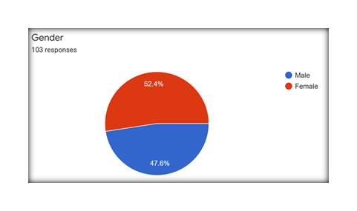
9) Discussion
Islam deliberately presents a systematic principle-centered approach to get rid of such challenges. However, if an individual is equipped with a true belief, he does not have fear of worries, sadness, disappointments arising particularly from contemporary challenges of this glossiness. Since, Imaan is the standard key to become successful, and happy in both worlds but we need to follow an authentic and effective source to build our faith stronger and healthy with logic, science, rational and philosophically-driven arguments for the best of life goals such as happiness, well-being, comforts and contentment in both worlds. In this regard the study deals with the key areas and grass-roots level approach to unfold the role and impacts of faith in human life.
The role of Said Nursi is not merely a preacher who calls the people for the development of faith, but a real demonstration who was the witness of the impacts of secularism on Islam. He knew how people divert just because of this materialism that entails to secularism.
9.1) What exactly deals with a Balanced Life:
Being Human, we are attributed to man(a creature which is characterized by some behavior or disposition such as gentleness, kindness, civil courteousness, obligation, sympathetic attitude, having tenderness, etc. towards others as befits a man) which is a composition of four things, body, heart, mind, and soul. The concept of Happiness, prosperity, and well-being come with a balanced approach that deals with the whole person’s body-mind heart, and soul.
The sustainability of human life requires to have the fulfillment of basic needs which are the essential components of human survival in this world. Both objective, (material wellbeing that deals with someone’s social and economic status or living standard) and subjective(life satisfaction, prosperity, happiness, or someone’s way of seeing and dealing with life) are the important components that deal with wellbeing.
Obviously, these are; the physiological (that includes food, warmth, air, water, sleep, shelter, move, etc.) for which we put efforts to eliminate this need for a reasonable survival. Then, we need, and what Maslow calls, to have a so-called safetyin life from childhood to all later periods, It’s a kind of predictability, positivism, that shunts fear from human life. In contrast to him, Hafiz Ghani, calls it, the intellectual needthat is much more important for a satisfying life. The third type deals with love, belongingness, affiliation, and emotions that require recognition from society. Maslow, describes it as self-esteem,the (fourth) level of human belongs to expectations which need to be fulfilled. Wealth, power, socio-fame, knowledge and recognition among the fellow human beings is the prime objective in this stage of human wellbeing.
The hierarchy of human needs can be derived with the following order:
9.2) Four faculties of human being
- Needs of Human Body/Physique
- Needs of Human Intellect/ Mind
- Needs of Human Heart/ Emotions
- Needs of Human Spirit/Soul
Since a balanced-approach person is one who deals with all basic components of human life equally and fairly. The only thing that you need to do, what Islam advises its followers with a guarantee of a successful, peaceful, contented life in both worlds, is to adopt the Islamic way/principles. These principles are well recognized by all the wise intellectuals around the globe. Following verses of the Holy Quran, “By the time. Verily, man is in the loss. Except those who believe and do righteous good deeds, and recommend one another to perform all kinds of good deeds, and recommend one another to patience.”clearly states the prime conditions to have a successful life in both worlds.
These verses and other verses like the first four verses of surah Al-Baqarah, the very first verse of surah Al-Mominoon and various other verses are adhering principle of success, prosperity and well-being in both worlds with the condition of FAITH & SPIRITUALITY.
Faith works better in such perspectives when it comes to actions which are a reflection of what you hide inside.
This definitely brings change inside you then it appears in actions which are the symbols of contentment and happiness. The holy Quran explicitly explains: “Surely, Allah does not change what is in a people until they change what is in themselves”. When faith is clearly addressed and transformed in a super felicitous way then individual’s life can be seen with a practical leading change in his behaviors. Following survey/graph01 highlights the status of the impacts of faith in humans’ behavioral change after studying the faith and spirituality in their practical life.
Table #02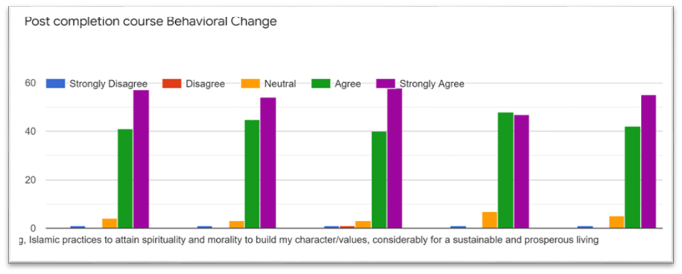
Hafiz Ghani has stated a short story in his book that emphasizes to change the world just by changing ourselves: God said to me, “your task is to build a better world. I answered, how can I do that? the world is such a large, vast place, so complicated, and I am so small and helpless. There is nothing I can do. But God in His great wisdom, said, just build a better you.”
93) Hierarchy of well-being, happiness, and success in Islamic Terms
Islam presents the hierarchy of successful and holistic wellbeing in the following three terms which deal with the concept of happiness, success, and prosperity:
- Al-Najah: النجاح Success, happiness or achievement of mere worldly things are for a limited time of period. As this word comes in the Hadith of the prophet (PBUH) ﷺ من صمت نجاہ" (whoever is silent he is saved)
- Al-Fouz: الفوزTo get benefited, and achieve salvation from loss for a long time that deals with religious perspectives particularly with hell and paradise. As this word comes in the holy Quran. فمن زحزح عن النار وأدخل الجنةفقد فاز (So whosoever is removed away from the Fire and is made to enter Heaven has indeed attained his goal.)
- Al Falah: الفلاح Success, achievement, salvation, happiness, wellbeing, and everlasting satisfaction that deal with every domain of human life in both of the worlds. As the word comes at numerous places both in Quran and Hadith of the holy Quran to discuss faith and faithful "قد افلح المومنون" (Verily successful are those who are faithful)
Islam calls for the biggest success, everlasting happiness and profound wellbeing in both of the worlds, but promises for those who are faithful. As it adheres “Verily successful are those who are faithful”. Allama Moudodi says: “the relation of Islam to Iman is the same as of a tree to its seed. As a tree cannot sprout forth without its seed, in the same way it is not possible for a man, who has no belief to start with, to become a Muslim”.
Faith, in Islam, is the primal condition of success and the foundationof all Islamic activities that lead a Muslim to awakening of mind, heart, soul, and body which bring enlightenment/spirituality.
10) Faith, its Development and Said Nursi:
Faith is a kind of trust in something from the bottom of heart to show a firm certitude in something. Zamakhshari says: To confirm, assure and to accept something from the core of heart presents the basic meaning of faith. In “the assurance of things hoped for, conviction of things not seen” In other words, it has been defined as faithfulness, and as such, it has been taken as an attribute both of the divine and believers in the divine. It is the value of faith that we face various storms, healing and find ourselves confident. The level of our success, achievement, and satisfaction in life depends upon the level of faith our faith we own. Johann Wolfgang von Goethe says: it’s a profound sense of security in regard to both the present and the future; and this assurance springs from confidence.” In Islam, “Faith Is generally referred to as the word of witness; sometimes called the creed. The whole essence of the teachings of Islam.”Keeping promise, loyalty, obedience, worship,etc. all these basic meanings and interpretations have a strong connection between happiness, and faith.
Islam, by its meaning peace, presents an important point to discuss contentment, satisfaction, and everlasting happiness that deal with both of the worlds. Since the belief in Islam is an exclusive pivotal position that provides a guided way to live blissfully, it provides a systematic way to attain happiness, prosperity, and well-being in a broader way. What we achieve in our life is the result of what we aimed for or how we see things through our lenses. It has a great impact on our success, destiny, prosperity, and happiness. Following beautiful proverb defines the role of faith in your achievement.
Sow a thought, reap an action;
Sow an action, reap a habit;
Sow a habit, reap a character;
Sow a character, reap a destiny
Faith in Scientific age:
In the classical ages, there was no need to discuss scientific doctrines with faith because the philosophers dedicated to those periods did not face any faith-based theological challenges.But now in this scientifically advanced spheres you need to be very compatible with the rational to justify your actions. According to Nursi, now everything needs to be proven and demanded to be justified. This tradition has changed the way to deal the presentation of Islam in such a way where Muslims face the challenges of modernity,and definitely when all this is proven that Islam and its practices and particularly belief is truth,it will give you happiness and inner peace that leads towards wellbeing, right direction and prosperity. Since inner satisfaction is the biggest happiness that leads well-being and prosperity, it provides inner awareness and makes the individual realistic and broader scope visionary person who builds sustainable values in the society.

Table#03 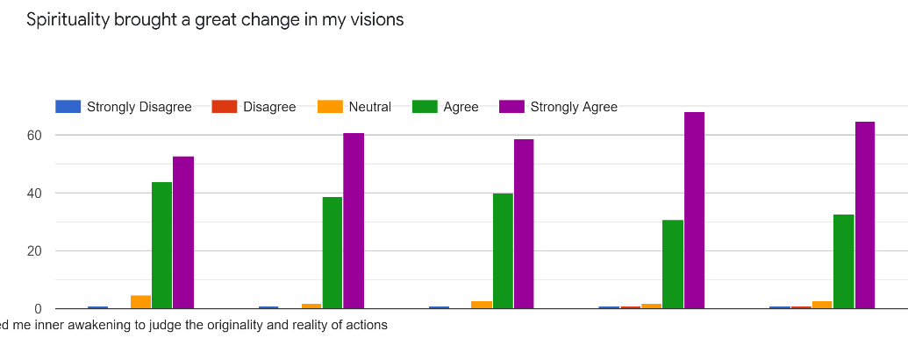

Nursi’s perspective in this regard is pretty clear as he knew, the real needs of the individuals in this challenging time and how to address them so he has presented two conditions. He is of the view that in today’s time people are more curious, conscious, and are overwhelmed by emotions as he has exemplified: people prefer an ounce of present pleasure over the tons of future (joys) happiness.that means people are more concerned about being than they are having. They do not enjoy the life that they are having rather they are worried about what they are not having. God has given unlimited blessings to thrive in this world but they do not utilize the faculties and get indulged in otherworldly affairs. To him: “The only way of saving them from this love of the world and from the danger of succumbing to it is by showing them the hell-like torments and pains they suffer even in this world.” Since faith is the cure, safety, and above all a central key to having a successful living so we need to strengthen our faith for a quality life.
Ways to develop Faith:
When this is the importance and significance of faith in our achievements we need to strengthen our faith for happiness, well-being, and prosperity in our life.
- Critical thinking,
- Stories of the Companions
- Repetition,
- Reading,
- Prophetic Traditions
- Noticing and Gut Feelings,
- Guide and Mentor.
- Scientific Exegesis of the Holy Quran
- Maslow says: Safety in childhood brings confidence and trust that builds faith in later his life [58].
Said Nursi is not a mere preacher who calls his people for the development of faith, but a real example of demonstration of the faith builder who was the witness of the impacts of secularism on Islam and saved the people through his letters in the form of Risal-i-Nur. He knew how people divert just because of this materialism that produces secularism. Nursi states “The Risale-i Nur’s function is to strengthen and save belief. We are charged with serving belief without differentiating between friend and foe, and without taking sides.
Measuring Faith (What standard level of faith is needed to have satisfaction and wellbeing in both worlds)
Faith is not something that you see and believe, but rather a practical experience that assures success, happiness, wellbeing and prosperity in both worlds. To achieve that level of faith you need to make effort for a required level of faith which is known as Imaan.
Levels of Faith:
- Knowing Based on mere information and knowledge علم الیقین
- Seeing Based on visits and seeing عین الیقین
- Doing Based on personal/ Individual experience حق الیقین
Hafiz Ghani in his book went to explain the levels of faith with the following classification:
- Islam اسلام
- Imanایمان
- Ihsan احسان
This above classification of faith is clearly defined and indeed, derived from the famous hadith of the prophet known as Hadith-e-Jibreel which teaches the stages of faith from external to internal. In other words: “the first stage is External-Islam/acts; the second is belief(Faith); and the highest degree of faith is highly conscious of the presence of God.” Iman is the central degree that actually is the targeted to be highlighted.
Islam does not make individuals as a standard to judge the quality/required-level faith of others rather it asserts the believers to see by themselves whether their faith is a quality level faith or not. Being a believer it is my own duty to see what level of faith I do own. In this perspective following three questions might be helpful for the assessment of a required level of faith that assures happiness, well-being prosperity, and ever success in human life:
- Does this belief (faith) help me improve the quality of my life?
- Does this belief (faith) help me become better person and attain self-actualization?
- Does this belief(faith) interpret phenomenon(reality) in an appropriate rational, scientific and spiritual manner?
When an individual finds himself a transformed and positively changed person, a morally better individual then his life can be seen as a true believer’s life with the happiness of life.
Below research shows how the study and then application of faith brings a leading change for the best of individuals.
Table #04 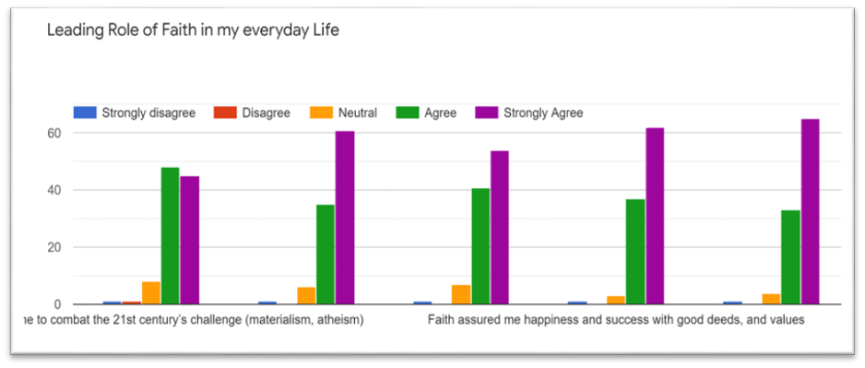
The holy Quran explicit the following five fundamental units to be believed firmly:
- Faith in Allah’s oneness
- Faith in angels
- Faith in divine books
- Faith in Holy prophets
- Faith in Hereafter (life after death)
Since faith in God is the supreme belief in Islam all other believes revolves around His oneness, majesty, power, knowledge and all His characteristics which are visible to us or not, it assures the wellness, prosperity, happiness, etc.in both worlds. Belief necessitates affirmation of divine unity, affirmation of divine unity necessitates submission to God, submission to God necessitates the reliance on God, and reliance on God necessarily leads to happiness in this world and the next.
Below survey/graph 03 addresses the status of the impacts of the faith in God after getting a clear understanding of the role of this faith in human life.
Table # 05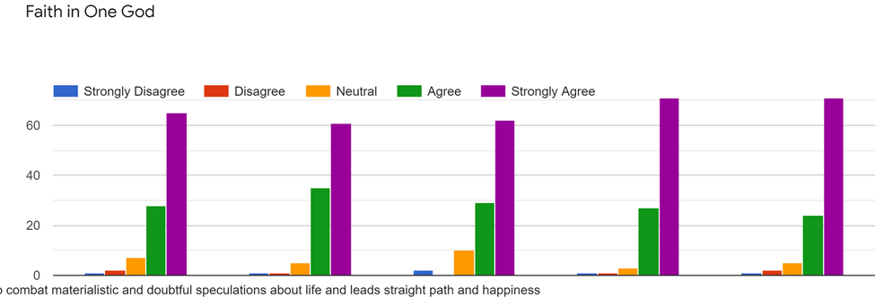
Said Nursi in his Risal-i-Nur makes the holy Quran as a foundation source of happiness. “Everything necessary for man’s happiness in this world and the next is found within it in relation to its worth”. Then almost in every parts of The Risal-i-Nur he emphasizes on the oneness of Allah the almight a central theme of prosperity for instance: “For us God suffices, and He is the Best Disposer of Affairssame is the case with every collection from Risal-i-Nur, like in THE RAYS, FLASHES, THE LETTERS, and in The WORDS to emphasize in the whole being, presence, divine unity and His controlling power all the way in his letters for the best of people.
Conclusion:
Since the rapid advancement in science and technology has changed the paradigm of human being both individually and socially, it has brought very influential challenges to human-being both internally and externally. Materialism, as one of the biggest challenge to humanity, has not only ruined the individual behaviors, but it has also snatched the social and cultural values from the human being. As a result, it has produced discomfort, anxiety, hopelessness, and denial of both individual and social well-being. To combat these challenges, Faith, which is the most felicitous, compatible, and effective source, produces new hope, satisfaction, happiness, prosperity, and well-being in both of the worlds if it is transformed and demonstrated with professional manners. The role of Said Nursi, in this challenging time of the 21st century, does not appear as a preacher only, but rather a reformist and revivalist with an indispensable synergy to refute such problems for the revival and building of the human being. His approaches bring back the values of the human being for the best of both the worlds but this is not enough for the higher goals. To achieve the higher and broader goals, Risal-i-Nur presents a sound, adequate, and compatible commentary of the Holy Quran with the Sunnah of the prophet Muhammad (PBUH) that deals with the whole person’s body, mind, mind, heart, and soul. But it requires, to hold the balance in each of the four faculties of human. We need to spread the teachings, practices, and demonstrations of Said Nursi which specifically are presented in Risal-i-Nur to bring happiness, well-being, and prosperity to the individuals across the Muslim communities.

Questioner:
“Faith & Spiritualty” A Statistical Study of the Impacts of faith on students’ behavior (What they feel at individual bases)
Demographic part
1.Name of the Institution--FCCU----------Section---------------Name (Optional) -------------- Roll No………. Nationality: ……………… Did you take any course in foreign country…………? If yes, then where …………... How much time you spent for study abroad………
Gender; a) Male ………… (b) Female…………. Majoring in: BS. ……………….
Semester: …………………. Previous Religious Education (if any): ….
Qur’anic Education: (a) Nazra………… (b) Hifz…………. (c) More/other……………
Offer prayers: (a) Five times a day…………(b) not regular………….... (c) ever……… ….
Recite the Holy Quran: a) Daily…………. (b) sometime…………. (c) ever ………….
Attend religious ceremonies as Milad……. Naat……. preaching…. Majlis……. etc.: a) regularly (b) sometime (c) ever (d) never
Parents talk at home on belief: often……… b) sometime………… c) Never…………………
Faith-based Questioner about the impacts on students
 | Leading Role of Faith in my everyday Life | Strongly  Disagree | Disagree | Partially agree | Agree | Strongly Agree
1 | Faith has built me to combat the 21st century’s challenge (materialism, atheism)
2 | Faith built strong willpower within me to become responsible and realistic
3 | Faith leads me to explore scientific, philosophical and rational approaches to explore truthfulness and reality principles for sustainable development
4 | Faith assured me happiness and success with good deeds, and values
5 | Faith taught me to respond to every inhuman, unethical action peacefully
6 | Faith lead me to a balanced life that brings happiness and well-being
 | Faith in God
 | Faith in God provided me a strong confidence to combat materialistic and doubtful speculations about life and leads straight path and happiness
 | Rational, philosophical and theological arguments in His existence directed me to find Him as ultimate hope in every challenging times
 | Faith in one God, brings unity among believers
 | Faith in God, significantly empowers believers with courage, braveness, and ever consciousness to compete the 21st century’s challenges
5 | Faith in God, shunts all kind of fears, doubts and misunderstandings about life and leads the individuals comfort, satisfactions, and contentment.
 | Spirituality
1 | Spirituality provides me inner awakening to judge the originality and reality of actions
2 | Spirituality prepared me to study the stages of human mind, both describes by Quran and Science, to understand of human (psyche) and all kinds of desires
3 | Spirituality taught me a life beyond the Physical Realm
4 | Islamic way(Knowledge, devotion, self-mastery, service, energy) of getting spirituality provides me a systematic approach towards human building
5 | The Islamic way of Self-transformation helped me to become realistic, conscious mind and inner awakened to identify right vs wrong, good vs bad, bright vs dark, glamour vs repulsion, truth vs lie etc.
 | Observation of Faith in daily life  (Post Completion Course assessment of faith in daily life) | Strongly  Disagree | Disagree | Partially agree | Agree | Strongly Agree
1 | After the completion of this course, I am able to consider the role of faith in human well-being, Islamic practices to attain spirituality and morality to build my character/values, considerably for a sustainable and prosperous living
2 | I am able, to consider, now, the meaning of quality of life and how effectively this course assist me to achieve my designed goals for the best in both of the worlds
3 | Practically, the principles, which I personally derived to solve the daily life problems in life, both from the Quran & Sunnah of the prophet(PBUH) are very compatible in my professional life
4 | The course has transformed me to set the big but smart goals in life and apply the Islamic principles of success, well-being, prosperity and happiness in life
5 | I felt myself a responsible, effective and ethically empowered member of society who can defeat every materialistic challenge both in individual and social life
Thank you very much for your time, have a blissful future
Dr. Nisar Ahmad Assistant Professor of Religious(Islamic) Studies Forman Christian College University Lahore

References

Serif Mardin, Religion and politics in modern turkey, in James p. pisacatori(ed.), Islam in the political process (London 1982) p.289-290
Nursi 1996a: 127 https://scholar.googleusercontent.com/scholar?q=cache:QFJMHo0QDdAJ:scholar.google.com/+Nursi+1996a:+127&hl=en&as_sdt=0,5&as_vis=1#:~:text=33,that%20quoted%20William
Al-e-Imran 03 :109
Nursi 1996a: 127
Nicolo Boivin, Material Cultures Material Minds, the impacts of things on human thought society, and evolution, (New York: Cambridge university press,2008) p168
https://onlinelibrary.wiley.com/journal/25781863 retrieved on 6/9/2021 at 18:34
Myron Weiner, modernization: the dynamics of Grow, (Cambridge: mass,1966) P03
Langdon Winner, the whale, and the reactor: a search for limits in an age of high technology, (Chicago: University of Chicago Press, 1986) p147-150
Belk RW (1984b) Possessions and the extended self. J Consum Res 11:139–168
Richins ML, Dawson S (1992) A consumer values orientation for materialism and its measurement: Scale development and validation. J Consum Res 19:303–316
Golberg, M. E., Gorn, G. J., Peracchio, L. A. & Bamossy, G. (2003). Understanding Materialism among Youth. Journal of Consumer Psychology, 13(3), 278-288.
Paduska B (1992) Money, marriage, and Maslow ‘s hierarchy of needs. Am Behav Scit 35:756–770
Golberg, M. E., Gorn, G. J., Peracchio, L. A. & Bamossy, G. (2003). Understanding Materialism among Youth. Journal of Consumer Psychology, 13(3), 278-288.
Larsen V, Sirgy JM, Wright ND (1999) Materialism: the construct, measures, antecedents, and consequences. Acad Market Stud J 3:78–110
Kasser, T. & Ahuvia, A. C. (2002). Materialism values and well-being in business students. European Journal of Social Psychology, 33(1), 137-146.
Solberg, E. G., Diener, E., & Robinson, M. D. (2003). Why are materialists less satisfied? In T. Kasser & A. D. Kanner (Eds.), Psychology and consumer culture. The struggle for a good life in a materialistic world (pp. 29–48). Washington, DC: APA.
Al-Nahal 16: 125
Nursi1996b: I,682, Lem’alar, copied from Andrew ripen, the Islamic world, (New York: Routledge Taylor &Francis Group, 2008) P400
Andrew ripen, the Islamic world, (New York: Routledge Taylor &Francis Group, 2008) P400
Said Nursi, Lem’alar, (Istanbul: Süzler publications 2013), 111-2
Ibid
Said Nursi, Lem’alar, (Istanbul: Süzler publications, 2013), 2-111) copied from, Hafiz Abdul Ghani, Twentieth Century Islamic Thought and the Challenges of Modernity (A Study of the Perspective of Bediuzzaman Said Nursi) Pakistan Journal of Islamic Research Centre, Baha Uddin Zakariya University Multan, Pakistan, Vol.20 Issue 02, December 2019), 33-44
Said Nursi, Lem’alar, (Istanbul: Süzler publications, 2013), 2-111 copied from, Hafiz Abdul Ghani, Twentieth Century Islamic Thought and the Challenges of Modernity (A Study of the Perspective of Bediuzzaman Said Nursi) Pakistan Journal of Islamic Research Centre, Baha Uddin Zakariya University Multan, Pakistan, Vol.20 Issue 02, December 2019), 33-44
Ibid
Andrew ripen, the Islamic world, P397
Ibid
Edward Mortimer, Faith, and Power, Great Britain: The Thetford press, Thetford, 1982) p152
Nursi, The Damascus Sermon, trans. Şükran Vahide (Istanbul: Sözler, 1989), 18-19
Ibid
Paul Abrecht, Faith, and Science in a Un Just World” 1980, Switzerland, Imprimerie Corbaz, Montreux) V2p29
Who got published various articles and books on Said Nursi and his books such as, Islam in Modern Turkey, towards an Intellectual Biography of Said Nursi are well address Said Nursi
The Istanbul Foundation for Science and Culture, Who Was Said Nursi? A BRIEF LOOK AT BEDIUZZAMAN SAID NURSI’S LIFE AND THE RISALE-I NUR, accessed on June 30, 2021, https://www.bediuzzamansymposium.com/en
Sukran Vahide, Towards an Intellectual Biography of Said Nursi, P 13“
Bediuzzaman Said Nursi’s Works,” accessed June 30, 2021, https://www.nurpublishers.com/about-said-nursi/his-works/
Currently She is working as an assistant professor of Islamic Studies in the same university
Hafiz Ghani, “Twentieth Century Islamic Thought and the Challenges of Modernity (A Study of the Perspective of Bediuzzaman Said Nursi” (BZU, Multan: Pakistan Journal of Islamic Research, 2018), Vol: 20, Issue: 2
Qaisar Mohammad, A brief sketch of the memories of the life and the works of the Said Nursi, Analisa Journal of Social Science and Religion Website Journal: http://blasemarang.kemenag.go.id/journal/index.php/analisa https://doi.org/10.18784/analisa.v3i02.686
Al-Asar 104:1-3 , 85: 11
William Little, H.W. Fowler and Jessie Coulson Revised (3rd Edit) edition by C.T. ONIONS The shorter (1973) Oxford English dictionary V.01, Pp994 Oxford University Press, New York USA 1973
Mircea Eliade, (1987) The encyclopedia of religion, Macmillan Publishing Company, New York Vol.6 pp500
Philological Society (1933) (reprinted in 1970) The Oxford English Dictionary, V.(H-K) Pp444 Oxford University Press, Ely house London W. r
Allardt (1993) Having, Loving, Being: An Alternative to the Swedish Model of Welfare Research/The Quality of Life
Allardt (1993) Having, Loving, Being: An Alternative to the Swedish Model of Welfare Research/The Quality of Life
Abraham Maslow, H. A. (1943). Theory of human motivation. Psychological Review, 50(4), 370–396. https://link.springer.com/referencework/10.1007/978-94-007-0753-5
Hafiz Ghani, Faith, Spirituality & Character, P8-9
Abraham Maslow, H. A. (1943). Theory of human motivation. Psychological Review, 50(4), 370–396. https://link.springer.com/referencework/10.1007/978-94-007-0753-5
(Al-Asar, 104:1-3),
Al-Ra’ad,11: 13
Hafiz Ghani, Faith Spirituality and Character, P 201
Al-Tirmazi, Abu Eisa Muhammad Bin Eisa, Al-Sunan,(Riadh, Maktabah Darul, Islam) Hadith#2501
Al-Imran,03: 185
Al-Mominon,23: 01
Al-Mominon,23: 01
Modoudi, Syed Abu-ul-Ala., Towards understanding Islam, (Lahore, Idara tarjuman- ul-Quran, 1978) P23-24
Muhammad Ayyub, Islam Faith, and Practice, (Lahore: Sohail Academy,2001), P22
Ainni, Allama Badar-ul-deen, Umda-al-Qari sharah Sahih Bukhari, (Beruit, Dar-ul-Fikr, linashar-e-wa-al tu zee 2005) Vol,01 P163
Mircea Eliade, (1987) The Encyclopedia of Religion, 1987) p250
Ibid, P 250-251
Ibid, P 252
A.D Ajijola, The concept of Islamic faith, Lahore: Islamic publications, 1980) p18
Mircea Eliade, (1987) Encyclopedia of Religion, 1987) p252-3
Hafiz Ghani, P 34
Ibrahim M. Abu-Rabiʻ, “How to Read Said Nursi’s Risale-i Nur” (Albany: State University of New York Press, 2003), P 68.
Nursi, The Damascus Sermon, 23
Nursi, The Damascus Sermon, 24
Nursi, The Damascus Sermon, 19
Ibid
Abraham Maslow, H. A. (1943). Theory of human motivation. Psychological Review, 50(4), 370–396.
Nursi, The Rays, P 416
Bukhari, Abu Abdullah Muhammad bin Ismail, Al-Jami Al-Sahih (Riaz, Dar-ul-Islam) Hadith # 50 and 7477
Hafiz Ghani, Faith Spirituality and Character, P 45
Ibid, P, 47
Al-Nisa,04: 136
Nursi, The Letters / Sixteenth Letter - p.83

