Indonesia's Islamic History of Culture Coexistence and The Risale-i Nur Perspective: Revisited

Fertiana Santy¹

Abstract

For the past few centuries, the entrance of Islam in archipelagic Indonesia had been discussed widely by scholars in the Western, Eastern, and Muslim world from various perspectives. Apart from the debates and discussions that emerged in Islamic history – unlike in the Arabian Peninsula, or other parts of Asia, or in Europe – the spread of Islam in Indonesia was not through defence or warfare but was considered to have gradually propagated by means of trade activities as well as assimilation of local culture, local wisdom, and ancestral beliefs. Yet the religious uniqueness resulted from the acculturation of the dispersion of religion, in terms of symbols and architectures of houses of worship, worship rituals, as well as interactions and characteristics of typical followers may not have been probably considerably explored.
Based on a qualitative descriptive historical methodological approach and grounded theory method, this paper attempts at analysing the need for establishing a culture of coexistence and peace based on Badiuzzaman Said Nursi’s approach, as well as providing examples of the culture of coexistence throughout Islamic history of religious practices and discourses in Indonesia, which is relevant and necessary in context.

Keywords: culture coexistence, Indonesia, risale-i nur, Said Nursi, cultural pluralism, Islamic history.

¹ Dr. Fertiana Santy, MPPM, is an Indonesian civil servant working at the Bureau of Laws and International Cooperation – Ministry of Religious Affairs Republic of Indonesia. She’s alumnae of Institut d’Etudes Politiques Université d’Aix Marseille – France; Monash University – Australia; and Universitas Indonesia.
Introduction: Indonesia’s Complexity of Ethnicities, Languages, Religions and Faiths

The largest archipelagic country in the world that is now called Indonesia, has 17,491 islands, including 229 islands that are uninhabited and have not yet been named (BPS, 2019). With a total length of 5,150 kilometers from west to east, Indonesia is a country with the largest ethnic groups in the world; it is more than 714 ethnicities and 718 traditional local languages (some of them have their different written characters/scripts), as shown by figure 2 below (Kompas, 2020; Lewis, et al., 2016; BPS, 2015; Na’im & Syaputra, 2011). One could argue that this enormous amount of diversity is peerless across the world. In addition, there are six religions “admitted” officially by the government: Islam, Protestantism, Catholicism, Hinduism, Buddhism, and Confucianism (Khong Hu Cu), which means government may subsidize and regulate each religious institution. These six religions have the most followers amongst the Indonesian people, and as a consequence, they receive guarantees, assistance, and protections as provided by the 1945 Constitution.

Figure 1. Various Typical Physical Characteristic of Indonesian People
from West [Aceh] to East [Papua]
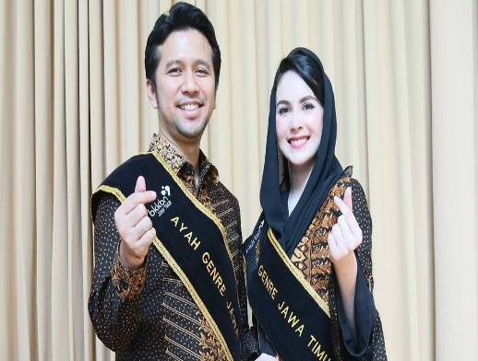
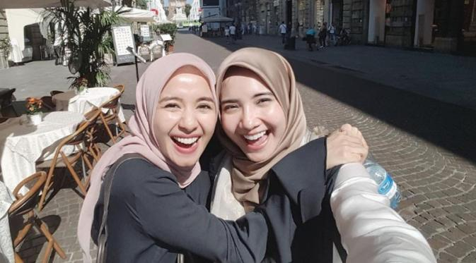
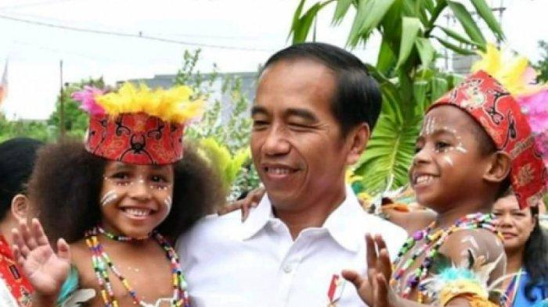
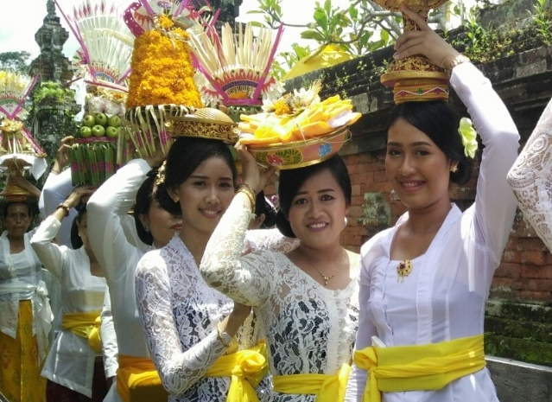

Source: Instagram, Pinterest (2021)

However, aside from those six religions, there exist also other faiths/religions such as Judaism, Zoroastrianism, Shinto, Bahaism, Taoism, Animism, Dynamism, Momolianism, Saminism, Kejawen, Kaharingan, Sunda Wiwitan, Parmalim dan Pemena, Marapu, Aluk Todolo, Kapitayan, Buhun, Jingi Tiu, Masade, Wetu Telu, Naurus, Wor, Tolotang, Subud, Sumarah, etc. This does not necessarily mean that these “other” religions or beliefs (apart from the six religions) are simply banned in Indonesia. They also got a full guarantee as provided by the 1945 Constitution, and are allowed for their existence, have rights to carry out the worship according to their beliefs, including establishing the house of worship, for as long as do not violate rules and regulations.
Although the country has a Muslim majority, yet neither it is an Islamic Republic (Islamic State) nor is it a secular State since it does not stipulate one particular religion to be the State religion or official religion. Rather, it is based on Pancasila. Furthermore, considering the complexity of ethnicities, languages, faiths, and religions; it is, therefore, paramount to maintain, manage, and nurture harmony and peace, because the more diverse ethnoreligious demographic structure of one region, the higher potential for socio-politico-cultural-religious conflict.

Figure 2. Different Types of Written Characters/Scripts of Local Languages
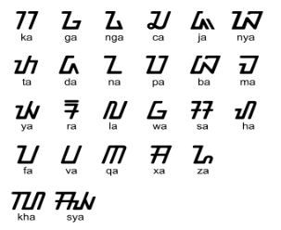
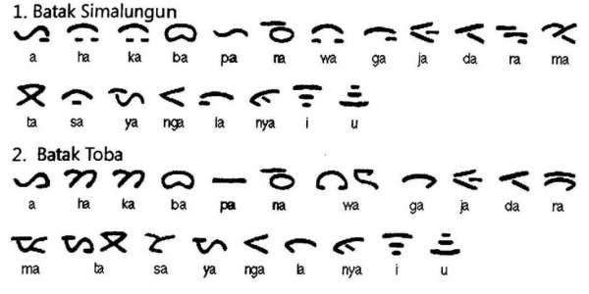
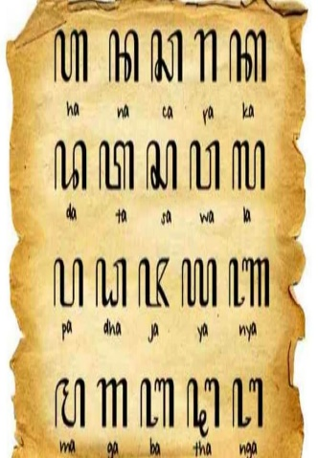
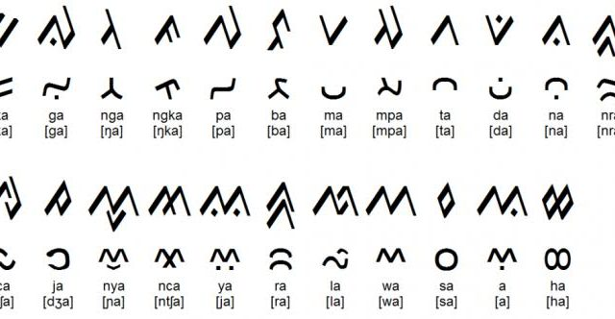
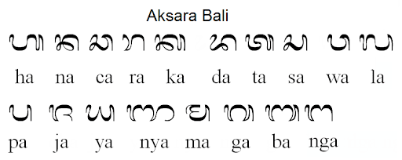


Realizing the reality of this plurality, since its inception, the Indonesian nation has chosen the motto of the State: “Bhinneka Tunggal Ika” (Unity in Diversity), which means albeit we are different (in ethnicity, language, or religion) but we are still one unity of Indonesia. Indonesian people should therefore be grateful that the founders of the State have managed to create common bonds for diversity and pluralism. These bonds and spirits are crystallized in the collective consciousness and contained in the Youth Pledge 1928, an oath to maintain integrity, harmony, and peace; and a pledge stating that one nation that is Indonesia, one language that is Bahasa Indonesia, and one homeland that is Indonesia.
This paper provides an overview of Indonesia's Islamic cultural coexistence, which reflects the plurality as well as the diversity of religious practices and discourses throughout Islamic history, thus forming a socio-cultural-religious uniqueness of adherents. Secondly, this paper examines how these cultural coexistences are expressed in symbols and architectures of houses of worship and in rituals, and how the people interact and mingle with one another in visceral cultural-religious assimilation. Thirdly, the analysis of the paper also discusses the historiography of Islam in archipelagic Indonesia and how it is relevant and in context with the Risale-i Nur perspectives of peaceful cultural coexistence in an exceptionally multi-ethnic-religious society.

Theories of the Entrance of Islam in Archipelagic of Indonesia

Prior to Islam becoming the most widely embraced religion by Indonesians, the population of the archipelago adhered to Animism, Dynamism, Momolianism, Saminism, Hinduism (particularly Shaivism tradition), Buddhism, and other local traditional ancestral beliefs (Galbinst, 2019). The majority of the population was Hindus and Buddhists, as evidenced by the many relics of the largest Hindu and Buddhist temples in the world (Galbinst, 2019). Historians, although the debates still exist, provide 4 theories on how Islam entered the archipelago. Each theory is explained based on a different time span. Starting from the 7th century until the 13th century (Azra, 2006; Ricklefs, 1991; Widjojoatmodjo, 1942).
First, Gujarati theory was proposed by G. W. J. Drewes and developed by Snouck Hugronje, J. Pijnapel, W. F. Sutterheim, J. P. Moquette to Sucipto Wirjosuparto (Yusuf, 2016; Moquette, 2001; Hurgronje, 1908). This theory considers that the entry of Islam into the archipelago was brought by traders from Gujarat, India in the 13th century AD. They passed through the Malacca Strait and made contact with the indigenous people in the western part of the archipelago which later gave birth to the Sultanate of Samudera Pasai, which was believed as the first and oldest Islamic kingdom in Indonesia. The theory is also reinforced by the discovery of the tomb of Sultan Samudera Pasai, Malik As-Saleh in 1297 with a Gujarat pattern (Hutauruk, 2020; Yusuf, 2016; Hurgronje, 1908). Moreover, the trade relationship between the people at that time has been established for a long time, through the trade route between Indonesia (Nusantara) – Cambay (Gujarat) – Middle East – Europe (Yusuf, 2016).
Second, Meccan or Arab theory was supported by J. C. Van Leur, Anthony H. Johns, T. W. Arnold, and Hamka. According to Hamka, Islam had spread in the archipelago since the 7th century AD brought by Arabs traders entering Nusantara (Isutzu, 1997; AlAtas, 1990; 1969). Hamka's statement was supported by T. W. Arnold who stated that Arab merchants had a fairly dominant trading activity in the archipelago. They married indigenous people, then formed a Muslim community and carried out Islamic da'wah activities (Burhanuddin & Dijk, 2013; Zed, 2001; Hamka, 1963).
Third, Persian theory. Umar Amir Husen and Hoesein Djadjadiningrat argued that Islam entered the archipelago through traders who came from Persia, not from Gujarat (Reza, 2009; Suwirta, 2000; Dyadiningrat, 1986). They insisted, at the beginning of the entry of Islam in the 13th century, the teachings that were prevalent in that era were Shia, originating from Persia. In addition, the existence of several similarities between Indonesian and Persian traditions is considered as one of the reinforcements. An example is the commemoration of the 10th Islamic-Persian Muharram which is similar to the commemoration ceremony called Tabuik/Tabut in some areas of Sumatra (Suwirta, 2000; Dyadiningrat, 1986). However, this theory is quite less convincing, since the majority of adherents of Islam are Sunni and Shafi’i school of jurisprudence (Pew Research Center, 2011; Pouwels, 2002; Pearson, 2000).
Fourth, Chinese theory. Jean A. Berlie (2004) in his book Islam in China: Hui and Uyghurs between modernization and sinicization mentioned that the first relationship between Arab Muslims and the Chinese was in 713 AD. The theory believed that Islam came into the archipelago exactly the same time as the Chinese migration to Southeast Asia. They entered the southern part of Sumatra (Palembang) in 879 or the 9th century AD. Other important shreds of evidence were that many Islamic preachers of Chinese descendants had great influences in the Kingdom of Demak, the first Islamic kingdom in Java Island, along with the collapse of the Kingdom of Majapahit in the 13th century AD. Some of the preachers were famously called Wali Songo (nine walis or nine sheikhs). The Kingdom of Demak was founded by Raden Patah, the son of the King of Majapahit from the wife of a Chinese woman who converted to Islam. Raden Patah also had a Chinese name, Jin Bun. He was the king of Demak and had religious advisors called Wali Songo since 1500 AD.

Cultural-Religious Harmony and Indonesian Legacy

History has recorded, religious culture coexistence and peace have been practiced and preserved centuries ago within the historiography of Islamic religious tradition in Nusantara. Unlike in the Arabian Peninsula, or parts of Asia, or in Europe – the spread of Islam in Indonesia was not through defence or warfare but was considered to have gradually propagated by means of trade activities as well as assimilation of local culture, local wisdom, and ancestral beliefs (Azra, 2006; Azra, 2005; Ricklefs, 1991; Widjojoatmodjo, 1942). The Muslim preachers use many local cultures such as wayang (traditional art performance presented by a puppeteer wearing traditional dress, using traditional classic puppets, and philosophically means a reflection, illustration, or portrait of life and the universe), gamelan, kulintang, angklung, kompang, kerenceng (traditional classical musical instruments), traditional classical dances, kidung (traditional classical chants or poems), gastronomy, arts, architecture symbols, etc. (Azra, 2006). These once sparked the debates and controversies since several conservative clerics, especially those from the Middle East, argued that music or musical instruments or dance is not permissible in Islam; according to them, the preaching of the religion should avoid those particular musical things. On the other hand, some others believed that Islam never prohibits music, dance, or other musical instruments, as long as they are not used for immoral actions and violating religious norms.
Some acknowledged Indonesia as one of the leading sectors and examples of best practices in the world for religious moderation and interfaith harmony in a remarkably plural society. Harmony amongst the people is not only seen in certain areas. Needless to say, it is a common phenomenon that can easily be found in every corner of Indonesia. There are lots of interesting testimonies from people who are also living witnesses or self-experience of religious harmony and tolerance. When respect and tolerance are embedded in each individual, therefore safe, secure, peaceful, and harmonious interactions between the communities will be established. In consequence, this condition will create national unity and harmony, where it is the foremost requirement of national development and prosperity.
The theory of social harmony involves five critical things that made the balance and harmony are feasible: values (whether the value of one group contradicts to others or not), idealism (whether the target objective contradicts or not), structure (whether the social structure is limp or normal), reciprocity (is there any mutual or harmful relation), and interaction (whether an interaction is running normal or having a gap between groups) (Turner, 1978a; Turner, 1978b). This nation has been long accustomed to living in a multi-cultural society, multi-ethnic, and multi-religions. Indeed, this typical various society is likely highly vulnerable to producing conflicts and frictions. In fact, the archipelago has successfully proved a form of a social system that is capable of managing internal conflict and at the same time creates a unifier mechanism to address social issues.
Based on the explanation of socio-historical context, there are many traditional and local wisdom which have been built by the community in order to create an atmosphere of harmonious and peaceful life in a pluralistic society. Take these as examples: tradition and philosophy of pela gandong (bonds of unity by fostering fraternity one another), and gendong beta-gendongmu jua (my pain is yours too) in Maluku. Tradition and philosophy of torang samua basudara (we are all brothers and sisters); mapalus (helping each other); tulude-maengket (working together for harmony); baku-baku bae, baku-baku sayang, baku-baku tongka, baku-baku kase inga (be kind to each other, love and care for each other, guiding each other, reminding each other); sitou timou, tumou tou (support each other and live the life, humans live for other humans) in Minahasa Sulawesi Utara. Tradition and philosophy of thong ngin fan ngin jit (living harmoniously together in spite of different religions, ethnicities and races) in Bangka Belitung. Tradition and philosophy siro yo ingsun – ingsun yo siro (equality, egalitarianism, and fraternity) in Jawa Timur. Tradition and philosophy of sambatan (helping each other) in Yogyakarta. Tradition and philosophy of weak hano lapukogo (together through happiness and hard times); ninetaiken o’pakeat (one heart one feeling) in Wamena, Papua. Tradition and philosophy of momosat (helping each other); moto tabian, moto tampiaan, moto tanoban (love and care each other and mutual improvement) in Bolaang Mangondow, Sulawesi.
Tradition and philosophy of sipakatau (saling mengingatkan), sipakalebbi (saling menghormati), mali siparappe, rebba sipatokkong (saling mengingatkan, saling menghargai, saling memajukan) in Bugis, Sulawesi. Tradition and philosophy of toraranga (reminding each other), rasa risi roso nosimpotobe (empathy, mutual perspective, assisting each other) in Kaili, Sulawesi Tengah. Tradition and philosophy of sintuwu maroso (strong unity despite many challenges, problems, differences of ethnicity, religion, race) in Poso Sulawesi. Tradition and philosophy of kolosara supremasi samaturu, depo adha (unity, mutual cooperation, mutual respect) in Sulawesi Tenggara. Tradition and philosophy of manyama braya (fraternity), tat twam asi (together through happiness and sad times), tri hita karana (three causes of happiness): i). pariangan (harmony with God), pawongan (harmony with fellow humans), and palemahan (harmony with nature) in Bali. Tradition and philosophy of lindung melindung bak daun sirih, tudung menudung bak daun labu, rajut merajut bak daun petai (caring and helping each other and mutual respect) in Jambi. Tradition and philosophy of sakai samboyan (togetherness and helping caring each other), alemui nyimah (respect guests), bejuluk beadok (giving good titles/names to other people) in Lampung.
Tradition and philosophy of saman as an art, thariqah (methode/guidance), the path of zikr (remembrance) and equanimity, as well as symbols of magical powers which create harmony, mutual cooperation in building social harmony; in Pandeglang. Tradition and philosophy of kayuh baimbai (cooperation), gawi sabumi (helping each other and working together), basusun sirih (wholeness), menyisir sisi tapih (introspection) in Kalimantan Selatan. Tradition and philosophy of adil ka’talimo, bacuramin ka’saruga, ba sengat ka’jubata (fair and justice, heavenly God Almighty), rumah betang (together and tolerance), handep-habaring hurung (value of togetherness and mutual cooperation) in Dayak Kanayatri Kalimantan. Tradition and philosophy of janji baba’s ando (promises must be kept), janji pua’ take japu (promises are not only words) in Dayak Bekati Kalimantan. Tradition and philosophy of murip ngenai (prosperity), te’ang liray (excellent among others, healthy competition) in Dayak Bahau Kalimantan. Tradition and philosophy of saling jot (giving each other), saling pelarangin (mutual mourning), saling ayon (visiting each other, friendship), saling ajinin (mutual respect), patut (good, commendable, not exaggeration/extravagance, patuh (harmonious, obedient, peaceful, tolerance, mutual respect and appreciation), patju (dilligent, resilient), tatas, tuhu, trasna (knowledgeable, moral/ethical, sociable) in Nusa Tenggara Barat. Tradition and philosophy of bareng anyong jari sekujung (unity to be stronger) in Sasak Lombok.
Tradition and philosophy, as above explained, have been echoing the message of harmony, tolerance, altruism, and peace, as well as seeking a common platform. The concept of life and the philosophies have been well-understood, well-implemented, and successfully co-managed and preserved for centuries in every corner of Indonesia, even though the influences of foreign cultures might creep in and erode the local traditional culture, but the wisdom still perpetuates. Some anthropologists and historians opined that this situation can be categorized as a local genius, acting as a counterbalance to the incessant influence of external pressure. It is also can be interpreted as the intelligence of local people to modify and adjust the influence of foreign culture into an existing culture in order to create peaceful-harmonious-life based on “local tastes”, and often at the same time, the modification and the adjustment also generate a specific form or identity of an area, or a district, or even an ethnicity (Sukarata, 1999).
The acculturation that occurred from the dispersion of religion had resulted in uniqueness - in terms of symbols and architectures of houses of worship, in terms of worship rituals/procedures, as well as in terms of interactions and characteristics of typical followers - that makes them peerless across the world. Below are several from the abundance of examples of real-life stories, together with some pictures of interreligious harmony in Indonesia. This obviously highlights a huge real portrait of religious harmony and tolerance, which is inevitably the descent legacy of Indonesia.

- Mosque of Al-Hikmah and Christian Church of Javanese Joyodiningratan (GKJ)
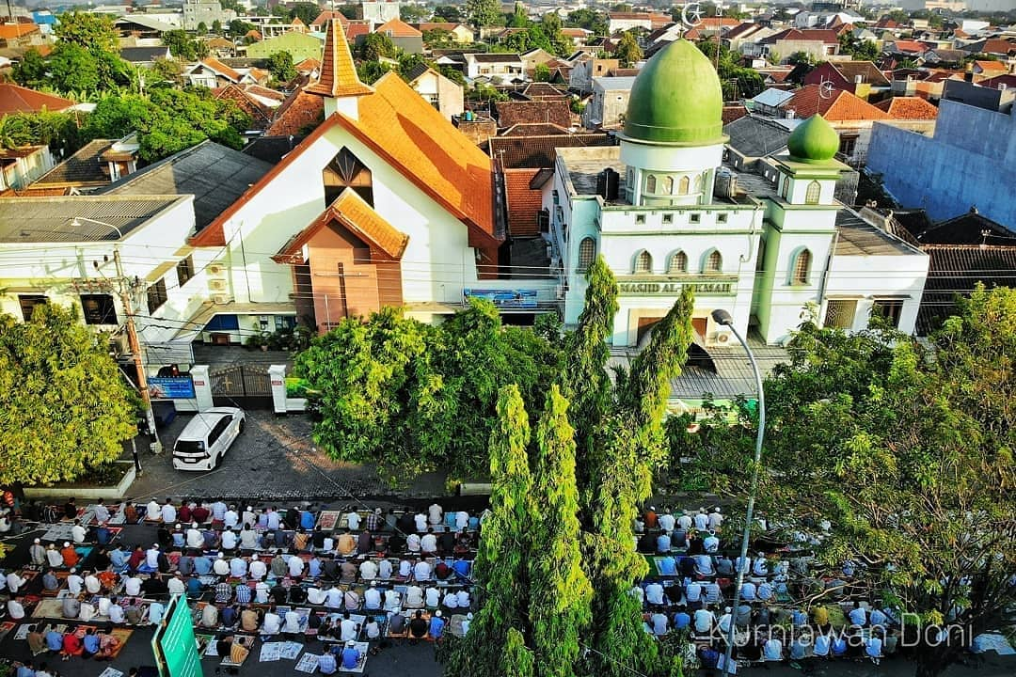
These two distinct houses of worship are located in the city of Solo, Surakarta, built side by side (the Church was in 1929, whereas the Mosque was in 1947), on a piece of land and attached to each other with the same address number: 222, for correspondence purposes. Both Mosque and Church community members are very proud of the fact that they are physically united. And there is no intention of both parties at all to replace the reality of the same shared address.
Muslims come and pay courteous visits to the Church on Christmas, especially after the service is through, and vice versa, the Christians also have a respectful visit during Eid Al-Fitr and Eid Al-Adha.

- Istiqlal (Mosque) and Katedral (Church)
The Istiqlal was built in 1961 and the Cathedral was built in 1889, located in the centre of Jakarta, are obviously the most noticeable compared to the other buildings in the vicinity of a town, and also considered as one of the capital’s icons. Both buildings are the symbols of major religions in Indonesia. They do not only give pride to their adherents but also to the people of Indonesia in general. The existence of those two big houses of worship placed vis-a-vis has shown that in the history of Indonesia, living together harmoniously amongst people with different religions is not an odd phenomenon. The evidence is clearly seen from the location of those two houses of worship which are adjacently placed.
The official name of this Church was "De Kerk van Onze Lieve Vrowe ten Hemelopneming – which means: “The Church Saint Mary ascending to heaven". Meanwhile, literally, the word “Istiqlal” means the expression of gratitude to Allah Subhanahu Wata’ala for His mercy in the form of the nation’s independence. Kiai Haji Ali Mustafa Yakub, the former Imam of the Istiqlal Mosque said, “this Istiqlal Mosque is a symbol of independence which forbids all people in the world to oppress one another.”

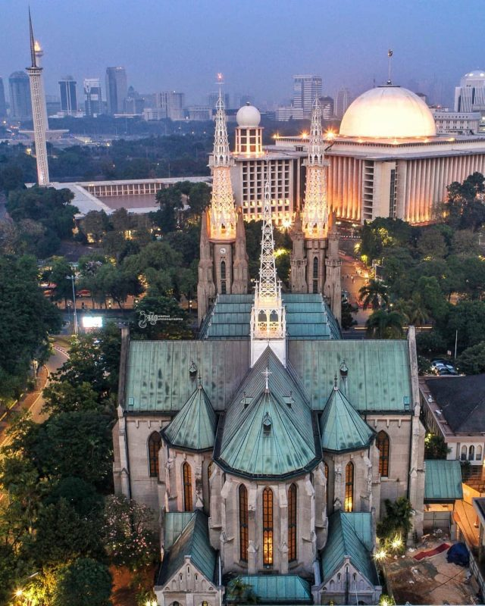
On Friday feast, the Istiqlal Mosque will be filled by Muslims who want to conduct the Friday prayer worship. Meanwhile, on Sundays, Easter, and Christmas, the Cathedral Church will be filled by the congregation. If the Church area has been full, especially during Easter and Christmas, the Istiqlal parking area will be used by the Christians. On the contrary, when the Muslims perform Eid prayer in Eid Mubarak and Eid al-Adha, they also use the shoulder of the road near the Cathedral Churchyard for parking.
Another interesting fact is the construction of the Istiqlal Mosque using the concept of Mr. F. Silaban - who is a devout Christian - describes a form of real tolerance. The Cathedral Church also employs some Muslims to work there. Anyone may visit both houses of worship, guests, or tourists.
The 44th President of the United States, Barack Obama, once visited Istiqlal Mosque in 2010 concluded, “the world should learn a lot about pluralism and religious tolerance from Indonesia”.

- Monument of Harmony in Minahasa
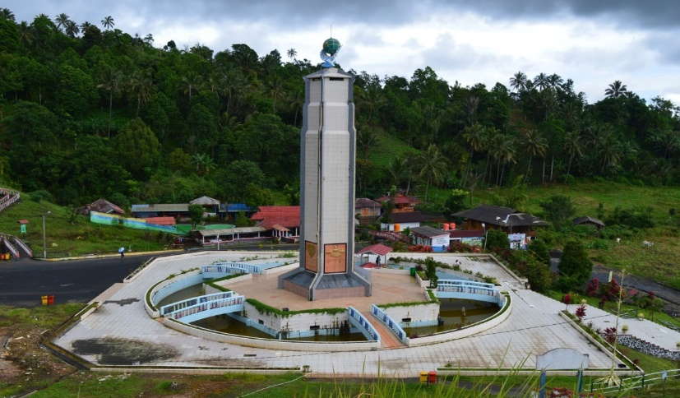
Bukit Kasih area which is located in the Kanonang village, district of Kawangkoan, the regency of Minahasa, Province of Sulawesi Utara, and known for its friendly weather, there appears 22 meters prism of Peace Tower monument, was built in 1999. It is a symbol of declaration that the communities in that area refuse and avoid religious or racial conflict or chaos. The monument of harmony in Bukit Kasih is the real symbol of tolerance among the interfaith community in that area. Looking from a proximate distance, we can see the easily-read carved relief contains the teaching of the tolerance of five religions: Islam, Protestantism, Catholicism, Hinduism, and Buddhism. Before we arrive at the top of the hill, there are five houses of worship from five religions located side by side: Churches, Mosques, Monasteries, and Temples. Because of this, Bukit Kasih is categorized as a place for spiritual tourism. In this area, visitors can do the worship according to their own faith/religion or they may just come by for taking a rest and enjoying the beautiful views. At the bottom of the hill, there is a thermal water spring that is hot enough for boiling corn or eggs to be sold to visitors.
There are written noble values of five religions on five sides of the monument:
For Protestantism, God’s commandment carved on the monument: ”Love your God with whole heart, soul, and power of thought, and love others as if you love yourself” (Matius 22:37039)
For Catholicism, the words engraved on the monument: “From the crusade, Jesus said that: This is your mother (Yoh 19:27). Remain in my love” (Yoh: 15:9).
For Muslims, it is engraved, Allah’s commandment: “…And help each other in righteousness and piety, and help not one another in sin and transgression and remain fearing Allah” (Al-Maidah: 2). …And We have not sent you (O Muhammad) except as a mercy to the whole universe (Al-Anbiya: 107).
For Buddhism, the teaching of Sang Sidharta Gautama which is carved “Namo tassa bhagavato arahato sammasam Buddhasa (praise the Bhagava the Holy one which has reached the perfect enlightenment) and he did not do any evil but always spread the good deed and clear up his mind” (Dhammapada XIV: 183).
For Hinduism, the teaching of Veda is sculpted: “He is not causing them to suffer, but he is creating salvation for all creatures and He gets eternal happiness.”
At the top of the monument, there is the statue of a pigeon and globe. Pigeon is an animal that reflects the symbol of chastity and faithfulness. The globe reflects the description of the fact that love is universal without any separator. Meanwhile, at the top of the hill, living in harmony is symbolized by the existence of five houses of worship built side by side.

- The Village of Three Towers of Pancasila
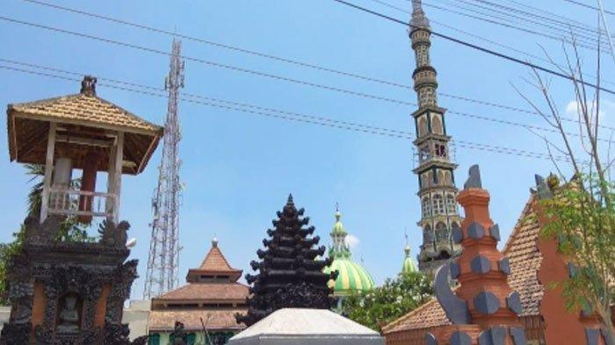
In Lamongan City, Province of Jawa Timur, there is a place which has a historical aspect, named Balun village exactly located in Sub-district Turi (Central Lamongan). This village is also called ‘The Village of Three Towers’ or The Pancasila Village. The Village of Three Towers derives from the existence of three religious buildings; Mosque, Temple, and Church which were built very close to each other. Thus, Balun is also called Pancasila Village as there are adherents from three different religions living harmoniously side by side without any conflicts. The varieties of religions have strongly enriched the cultural diversity of Balun village, and it is in fact being the unique identity as of the social interaction amongst the followers of multi-religions there.

The religious tolerance in Balun village is not only described by the existence of those buildings of worship (Mosque, Church, and Temple), but also it is being manifested into many forms. In the local ceremony of Balun village, Ngaturi, all of Balun people, no matter their religions, the people will wear hijab and a black traditional hat (kopiyah). While in other areas, hijab and kopiyah are generally admittedly a symbol of Islamic identity, on the contrary in Balun village, it is rather a symbol of culture. These symbols have created social interaction among the community become much easier. Moreover, in any kind of ceremony or religious celebration, such as Eid al-Fitri, Eid al-Adha, Christmas, and Galungan, they will invite others to join the events and they will wear traditional Javanese costumes. They perceive that the Javanese symbol in the ceremonies represents togetherness and harmony among the society in Balun village.

- Not only an ordinary Monastery: Avalokitesvara
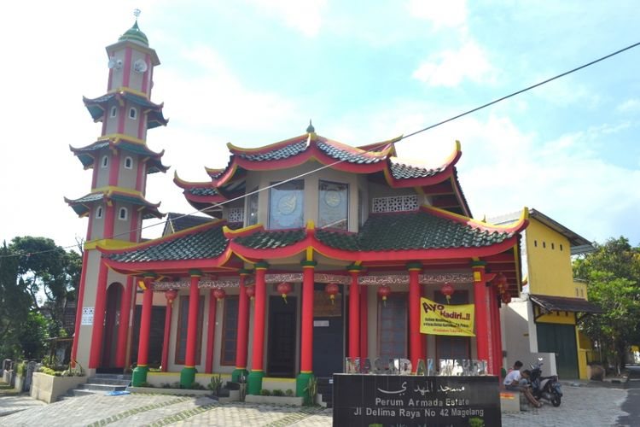
Monastery (Vihara) Avalokitesvara (Klenteng Kwan Im Kiong) is the second biggest Monastery in Java Island, located in the sub-village of Candi, village of Polagan, sub-district of Galis, district of Pamekasan, province of Jawa Timur. For the Chinese in Madura, the Monastery of Kwan Im Kiong, others would call Avalokitesvara Monastery, has its own uniqueness due to its long history and as the biggest Monastery in Madura, and is the form of the spirit of Bhineka Tunggal Ika.
The Monastery which covers three hectares, contains five shelters of worship, three kinds of supported prayers, and other facilities for different religions. The entrance has the type of Balinese’s architecture, and right at the left and right side of the Monastery stood two strong towers. The Monastery itself provides a place for praying particularly for Buddhists, Confucianists, and Taoists. Apart from that, alongside the Monastery, there are Hindu Temple and Mosque built around the complex area.

- Mosque Al-Mahdi
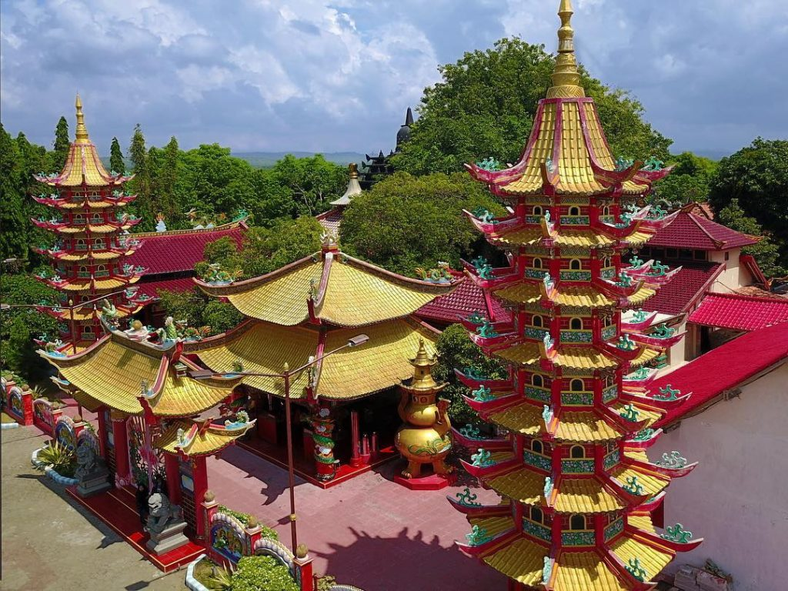
Located in Magelang, province of Jawa Tengah, this Mosque has typical Chinese architecture. On the left side of the Mosque, there is a tower about 5 meters high, each has four levels and is shaped in a hole. While at the top level there are loudspeakers and at the top of the tower there is a simple dome that reads the pronunciation of Allah. The similarity of the Mosque to the Confucianism Temple is how to place the lanterns, totaling 11 pieces, hang on the ceiling of the Mosque's hallway.

- Puja Mandala in Nusa Dua, Bali – Indonesia
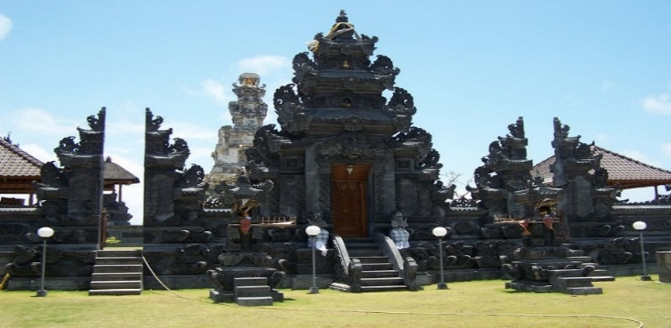
Puja Mandala is located in Kuru Ksetra road in Adat Bualu, village of Benoa, sub-district of Kuta Selatan, district of Badung, province of Bali, where there exist several houses of worship in close proximity: Catholic Church (Maria Bunda Segala Bangsa), Protestant Church (Bukit Doa), Mosque (Grand Mosque of Ibnu Batutah), Hindu Temple (Jagat Natha) and Buddhist Monastery (Buddha Guna).

- A glance portray of cultural coexistence of inter-religious harmony
President Joko Widodo regularly invited religious figures/leaders of all faiths to the palace in the framework of fraternal relationships and to discuss any issues related to religious communities. Another example of inter-religious harmony commonly happens across the country such as when celebrating each religious festive, they will invite other religious figures as a courtesy.
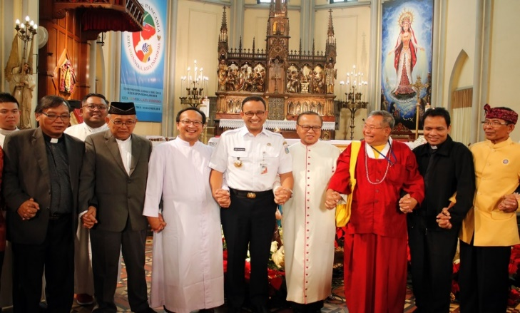
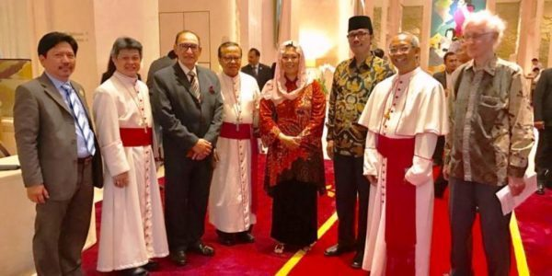
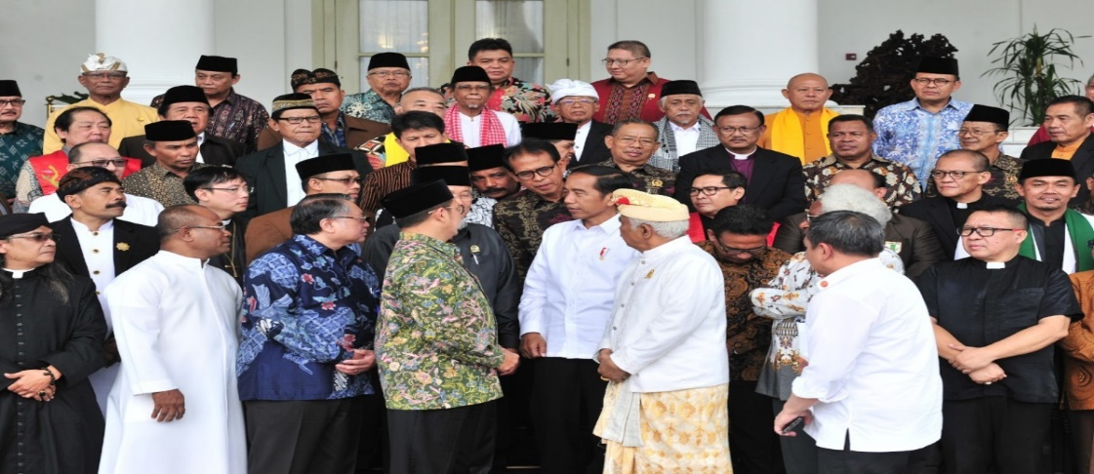

Risale-i Nur Perspective of Religious Cultural Coexistence
In The Letters, Nursi had put emphasis on the need for establishing culture of coexistence and peace, one of the most fundamental values in the Qur’an and Hadith. He insisted that the necessity for social solidarity, social stability, and peaceful cooperation are amongst religious obligation and core duty, not merely political agenda or national agenda (Nursi, 2009; 2007; 1996a; 1996b). He gave credence, as mentioned in the Qur'an verses 49:13 that Islam embraces peace and cultural pluralism, accenting that God has created and made human beings into races and tribes so that they should recognize one another and create good relations on social life. Where society needs to help one another and should not develop hostility or hatred towards each other (Nursi, 2009; 2007). Nursi was convinced that races and tribes are created in order to create mutual equal relationships as well as to serve the common goals of worshipping God. He added social solidarity will result in a mutual discussion and consultation (shūra) which is the principle of happiness and the development in Islamic social life (Ajmal, 2014).
Apart from being a great Muslim scholar or Ulema, Nursi was also one of the great Muslim figures interfaith dialogue in the 20th century, since he initiated and advocated sincere relations and trust between Muslims and non-Muslims (Dangor, 2009; Eris, 2009; Vahide, 2005a). As a concrete example, when Nursi himself took the initiative to contact the Pope Pius XII in Vatican in 1950 by sending copies of Risale-i-Nur and received positive and fruitful responses (Dangor, 2009; Eris, 2009; Vahide, 2005b). He also visited Ecumenical Patriarch Athenagoras the Greek Orthodox Patriarch of Istanbul in 1953 on the mission of cooperating with the Christians against the issue of atheism (Dangor, 2009; Eris, 2009; Vahide, 2005b). In Emirdag, during the Second World War, Nursi began to urge Muslims to consolidate and unite, not solely within the Muslim themselves but also with religious and pious Christians - regardless of some differences or disputes that occurred - for irreligion and atheism are invading, structurally and massively (Berghout 2004; Nursi, 1959). In his various books and articles, he developed peace theory and adopted the principles of qualitative analysis of multiculturalism that is applicable to many socio-cultural-religious disputes and tensions. His concept of religious cultural coexistence consists of interfaith and intercultural dialogues, religious moderation (washatiyyah), tolerance to other faiths, and mutual/common understanding, coexistence, and cooperation (Amaya, 2017; Majeed & Zanib, 2016; Mohamad et al., 2016; Ajmal, 2014; Dangor, 2009; Eris, 2009).
Interfaith dialogue is defined as “dialogue between members of different religions/faiths for the goal of reducing conflicts between their religions and to achieve agreed upon mutually desirable goals” (religious pluralism) (Dangor, 2009 p. 3). Consequently, interfaith and intercultural dialogues seek to develop understanding and confidence to prevent suspicions, mistrusts, and tensions. It is also able to resolve disputes and break the barriers, inclusivity, and generalizations; because the latters can prompt doubt, extremism, and radicalism (Ahmed, 2018). The rampant of terrorism and extremism recently, caused by lack of respect, tolerance, and dialogues, as well as perceptivity of few Muslims who consider that the mere obligation to fight infidels as jihad related to warfare and suicide bombing. Nursi, further argued that the most kind of jihad that is appropriate for the present age is spiritual or moral jihad (Vahide, 2006); hence zealotry and bigotry can be avoided and overcome with harmony between mind and heart which are filled by intellect/science and faith/religion (Nursi, 2013).
On the other hand, it is also interesting to note that some would argue Nursi's views on interfaith dialogue and his approach to adherents of other religions might be categorized as having similarities or intersecting the same views with religious pluralism (Dangor, 2009; Vahide, 2005a; Berghout, 2004). Religious pluralism consists of inter-religious understandings and mutual respect which encourage social harmony and peace (Zarkasyi, 2018). Therefore, in return, it will provide initiatives and alternatives for better social orders and peaceful life (Amaya, 2017). It is quite clear, during his lifetime, Nursi had put ample efforts in encouraging dialogues and culture coexistence, as he understands very well that the Quran itself call for dialogues (Dangor, 2009; Vahide, 2006; Vahide, 2005a).

Tolerance, mutual understandings, and cooperation are other three pivotal prerequisites in cultural-religious coexistence, based on Said Nursi (Mohamed & Said, 2019; Mohamed & Said, 2018; Embong, et al., 2017; Mohamad et al., 2016). They can solely be nurtured through respect, open-mindedness, kind-hearted, altruism, friendship, good relations, cooperation, and collaboration. When these characteristics become a common practice, correlatively, integration can be achieved in a diverse social environment. In other words, Nursi added, cultural-religious coexistence is an essential factor of socio-economy-political and national stability (Mohamed & Said, 2019). For these reasons, interfaith and intercultural dialogues should not only be concretely implemented at the official or academic level, yet also in the quotidian, which will create greater tolerance, closer ties of brotherhood, and establish a sense of settlement and sincerity (Ajmal, 2014; Maarif, 2009; Syam, 2009; Azra, 2006; Shihab, 2001; Shihab, 2000).
Moreover, one of the most prominent factors in embodying religious and cultural coexistence, besides interfaith dialogue, is through education (Maarif, 2009; Syam, 2009; Azra, 2006; Shihab, 2001). For instance, in the Risale-i Nur, Nursi was really concern and critical regarding teaching methods as well as curricula of madrasahs and seminaries which he described as ineffective and irrelevant for young generation to encounter the massive changes and challenges in the modern and contemporary era (Vahide, 2005a). He put emphasis on the integration between natural and religious sciences which he assured would “strengthen the truths of religion” (Vahide, 2005a, p. 29). Practically, he sturdily advised that religious and modern sciences can be taught both in public and religious schools (Vahide, 2005a).
Nonetheless, some are convinced that Said Nursi merely focused and was concerned on eradicating secular educations as it caused degradation of moral and religious values; and that secularism provided solely a weak and fragile social order. Vice versa, others would argue, Nursi indeed noticed there existed huge wicked impact not solely for extreme secular education, but also for extreme religious education. They highlighted that Nursi taught to be moderate or in the “middle”, neither to be extreme right nor extreme left. On account of this, Islam teaches washatiyyah (moderation) in religious perspectives and practices (Majeed & Zanib, 2016; Shihab, 2000; Shihab, 1996). In The Words, Nursi also urged that “minds should be enlightened with science, and hearts need to be illumined with religion. When two are combined, the truth will be revealed, yet when separated, there will be fanaticism in the first one and arise doubts on the latter” (Nursi, 2013).

Research Methodology
The research uses the combination of qualitative descriptive historical approach and grounded theory method (GTM). The strategy of qualitative descriptive historical approach is to collect written sources such as books, and articles in various scientific journals related to religious harmony in Indonesia as well as Said Nursi’s concept of peace and harmony in the multi-religious dimension. After verification, synthesis on scientific evidence with the purpose of enforcing the facts, and obtain strong conclusions or generalizations. The purpose is to make reconstruction of the past systematically and objectively.
On the other side, the research conducted here is not based on a preconceived hypothesis that needs to be tested – instead, it is focused on examining questions, “to explore a topic, to develop a detailed view, to take advantage of access to information, to write in expressive and persuasive language, to spend time in the field, and to reach audiences receptive to qualitative approaches” (Creswell, 1998, p. 24). Since the research involves real cases or real stories as the core idea of the research, thus it includes GTM. Indeed, cases or stories are data sources with a soul, and there is no methodology that values and honors those more than grounded theory. One of the mandates from the grounded theory is to develop theories based on real study cases or people’s lived experiences rather than proving or disproving existing theories (Glaser & Strauss, 1967). In grounded theory, we often do not start with a hypothesis, rather, focusing on examining questions or topics, developing a theory, and then seeing how and where it fits in the literatures (Ralph et al., 2015; Tolhurst, 2012; Charmaz, 2008; 2005).

Conclusion
The circumstance of the world today as consisting of conflict between the different national egoisms and the world peace is still a long one. There is an urgent to open up a path to the future that will preserve peace and harmony for nations and mankind. Throughout the history of mankind – races, religions, faiths – have often been the sources of certain wars and conflicts in the world (Svenson & Nilsson, 2018).
Millions of people have been exterminated, and many nations and civilizations are destroyed and extinct due to race or religious conflicts (Krause, 2015). Therefore we need to contribute something to overcome the human crises than stand aside from what’s happening before our eyes. The plurality of society, as mentioned in the Qur’an, cannot be denied. We need to co-exist peacefully, within the nation itself as well as with other nations of the world.
In fact, admittedly, the Muslim world today is facing faith/religious conflicts. Many Muslim countries or countries with predominantly Muslim populations are under a massive load of bloody wars and socio-religio-political conflicts. Multidimensional integration, cultural-religious coexistence, and social peace are obviously urgent to be implemented concerning preserving the civilization of humankind.
Interfaith dialogue and religious-cultural coexistence – which are quite often debated and considered unable to reach a common ground – have obviously been proven that they can sustainably be implemented with good intentions and heartiness. As mentioned above, Nursi had given some tangible examples on how to approach and promote dialogues with the aim of establishing a harmonious and peaceful society. Even though the practical manifestation of interfaith dialogue from what Nursi had undergone was especially “solely” between the Muslims and Christians, where probably in Turkey and in that era, the majority of the population consists of two adherents of Abrahamic religions. While on the contrary, in Indonesia, there has been existing a more complex and multi-ethnic-religious society; cultural coexistence and interfaith dialogues have been carried out from generation to generation with various religions and beliefs. Surely, contribution in maintaining and nurturing religious-culture of coexistence, harmony, and peace is a never-ending effort. In parallel, according to Nursi, the essential of the culture coexistence and peace itself is reciprocal, and has been becoming the core factor of social solidarity which will eventually result in socio-economy-political and national stability.

References

Ahmed, A. (2018). Afterword: A reflection. The Review of Faith & International Affairs, 0274(9), 1-6.

Ajmal, Muhammad. (2014). Globalization and the thought of unity in diversity of Badiuzzaman Said Nursi in the light of his magnum opus risalah al-nur. Indonesian Journal of Islam and Muslim Societies, 4(1), 135-153.

AlAtas, S., M., Naquib. (1969). Preliminary statement on general theory of the Islamitation of the Malay Indonesia archipelago. Kuala Lumpur: Dewan Bahasa dan Pustaka. p. 11.

AlAtas, S., M., Naquib. (1990). Islam dalam sejarah kebudayaan Melayu. Bandung: Mizan. p. 34.

Amaya, Y., T. (2017). A short history of religious pluralism and tolerance. IISTE, 39(2005), 1-4.

Azra, Azyumardi (2005). Dari Harvard hingga Makkah. Jakarta: Republika.

Azra, Azyumardi (2006). Islam in the Indonesian world: An account of institutional formation (p. 169). Jakarta: Mizan Pustaka.

Berghout, Abdelaziz (2004). The Muslim world and the West: Nursi’s vision for a new universal dialogue culture (pp. 19-39). In Bringing Faith, Meaning & Peace to Life in a Multicultural World: The Risale-I Nur’s Approach. Istanbul: Nesil.

Berlie, Jean A. (2004). Islam in China: Hui and Uyghurs between modernization and sinicization. Bangkok: White Lotus Press.

BPS (Central Bureau of Statistic) (2015). Mengulik data suku di Indonesia. Available from https://www.bps.go.id/news/2015/11/18/127/mengulik-data-suku-di-indonesia.html

BPS (Central Bureau of Statistic) (2019). Luas Daerah dan Jumlah Pulau Menurut Provinsi, 2019. Retrieved from https://www.bps.go.id/indikator/indikator/view_data_pub/0000/api_pub/UFpWMmJZOVZlZTJnc1pXaHhDV1hPQT09/da_01/1

Burhanudin, J., & Dijk, K., V. (2013). Islam in Indonesia: Contrasting images and interpretations. Amsterdam: Amsterdam University Press.

Charmaz, K. (2005). Grounded theory in the 21st century: Applications for advancing social justice studies. In N.K. Denzin & Y.S. Lincoln (Eds.), Handbook of Qualitative Research (3rd ed.) (pp. 507-536). CA: Sage Publication.

Charmaz, K. (2008). Constructionism and the grounded theory method. In Holstein, J.A. & Gubrium, J.F. (eds.), Handbook of Constructionist Research (pp. 397–412). New York: The Guilford Press.

Creswell, J., W. (1998). Qualitative inquiry and research design: Choosing among five traditions. Thousand Oaks, CA: Sage Publications.

Dangor, Suleman. (2009). Said Nursi's approach to interfaith dialogue. The Research Gate, 3. Retrieved from https://www.researchgate.net/publication/307924485_Said_Nursis_Approach_to_Interfaith_Dialogue

Embong, R., AbdulRahman, A., Ibrahim, M., Tee Abdullah, R., Adam, F., Syed Omar, S., H., Omar, N., A. (2017). Integrated education as a solution for educational dualism from Said Nursi’s perspective. International Journal of Social Sciences, 3(2), 914-928.

Eris, Suleyman (2009). Interfaith dialogue & alliance principles in the works of Said Nursi. The Fountain, 67.

Glaser, B., G., & Strauss, A., L. (1967). The discovery of gounded theory: Strategies for qualitative research. Mill Valley, CA: Sociology Press.

Galbinst, Yuri (2019). Islam: Dari Indonesia ke dinasti Safawi (pp. 13–14). Cambridge: Cambridge Stanford Books.

Hamka (1963). Sejarah umat Islam (edisi ke-4). Bukit Tinggi: Menara.

Hurgronje, Snouck C. (1908). L'Arabie et les Indes Neerlandaises. Revue de l'histoire des religions, 57, 60-80.

Hutauruk, A., F. (2020). Sejarah Indonesia: Masuknya Islam hingga kolonialisme. Yayasan Kita Menulis: Medan.

Izutsu, Toshihiko. (1997). Relasi Tuhan dan manusia: Pendekatan semantik terhadap Al-Qur’an. Yogyakarta: Tiara Wacana. p.3.

Kompas (2020). Indonesia punya 718 bahasa ibu, jangan sampai punah! Available from https://edukasi.kompas.com/read/2020/02/22/21315601/indonesia-punya-718-bahasa-ibu-jangan-sampai-punah?page=all

Krause, K. (2015). Religion, violence, and terrorism: An empirical evolutionary study. Skeptic (Altadena), 20(1), 48-56, 64. Retrieved from https://search.proquest.com/docview/1673049374?accountid=11862%0Ahttp://openurl.ac.uk/ukfed:kcl.ac.uk?url_ver=Z39.88-2004&rft_val_fmt=info:ofi/fmt:kev:mtx:journal&genre=article&sid=ProQ:ProQ%3Aeducation&atitle=Religion%2C+Violence%2C+and+Terrorism&title=S

Lewis, M. Paul; Simons, Gary F.; Fennig, Charles D. (2016). Ethnologue: Languages of the world, 19th edition. SIL International: Texas.

Maarif, A., Syafi’i. (2009). Islam dalam bingkai keindonesiaan dan kemanusiaan: Sebuah refleksi sejarah. Bandung: PT. Mizan Pustaka.

Majeed, M., T., & Zanib (2016). Al-Wasatiyyah in the practice of religious tolerance among the families of new Muslims in sustaining a well-being society. Humanomics, 32(1), 19-32.

Mohamad, M., Z., Adam, F., Embong, R., Shafie, B., Salleh, M., A., & Ismail, D. (2016). Strategies for unifying humankind through the empowerment of civilizational dialogue according to Bediuzzaman Said Nursi. Social Sciences, 11(24), 5824-5829.

Mohamed, M., & Said, T. (2018). Islamic education on science, peace, and development in thought of Said Nursi. Jurnal Studi Al-Qur’an, 14(2), 109-122.

Mohamed, M., & Said, T. (2019). Leadership effectiveness and social reforms in Risale-I Nur. Social Science Education Journal, 5(2), 71-79.

Moquette, J., Y. (2001). The propagation of Islam in the Indonesian Malay archipelago. In Aliyah Gordon (eds.). p. 30. Kualalumpur: MSR.

Na’im, A. & Syaputra, H. (2011). Kewarganegaraan, suku bangsa, agama, dan bahasa sehari-hari penduduk Indonesia: Hasil sensus penduduk 2010. Badan Pusat Statistik: Jakarta.

Nursi, Said (1959). Emirdağ Lahikasi. Istanbul:Sinan Matbaasi.

Nursi, Said (1996a). The Damascus sermon. Translated by Sukran Vahide. Istanbul: Sozler Publications.

Nursi, Said. (1996b). The Damascus sermon. (2nd ed.). Translated by Sukran Vahide. Istanbul: Sozler Nesriyat.
Nursi, Said. (2007). The letters, epistles on Islamic thought, belief and life. Translated by Huseyin Akarsu. USA: New Jersey.
Nursi, Said. (2009). Mektubat (The letters). Istanbul: Soz Publications.
Nursi, Said (2013). The words: On the nature and purposes of man, life and all things. Risale-i Nur Collection (7th ed.). Istanbul: Sozler Publication.

Pearson, M., N. (2000), The Indian ocean and the red sea. In The History of Islam in Africa (Nehemia Levtzion & Randall Pouwels Ed.). Ohio: Ohio University Press.

Pew Research Center (2011). The future of the global Muslim population: Sunni and shia Muslims. Retrieved from https://www.pewforum.org/2011/01/27/future-of-the-global-muslim-population-sunni-and-shia/

Pouwels, R., L. (2002). Horn and crescent: Cultural change and traditional Islam (pp 88–159). Cambridge: Cambridge University Press.

Ralph, N., Birks, M., & Chapman, Y. (2015). The methodological dynamism of grounded theory. International Journal of Qualitative Methods, 14 (4).

Reza, Imam (2009). Shia Muslims around the world. Retrieved from http://www.imamreza.net/old/eng/imamreza.php?id=3591

Ricklefs, M., C. (1991). A history of modern Indonesia since c.1300, 2nd Edition. London: MacMillan.

Shihab, M., Quraish (1995). Membumikan Alquran (Earthing the Qur'an) (pp. 272-278). Bandung: Mizan.

Shihab, M., Quraish (2000). Wawasan Al-Quran: Tafsir maudhu'i atas pelbagai persoalan umat (Insights of the Qur'an: The exegesis of maudhu'i on various and complex human issues). Bandung: Mizan.

Sukarata, Made (1999). Pengenalan dan pemahaman local genius menghadapi era globalisasi di Indonesia, in Journal of Design Visual Communication, 1(1), 43.

Svensson, I., & Nilsson, D. (2018). Disputes over the divine: Introducing the religion and armed conflict (RELAC) Data, 1975 to 2015. Journal of Conflict Resolution, 62(5), 1127–1148.

Syam, Nur. (2009). Tantangan multikulturalisme Indonesia. Yogyakarta: Kanisius.

Tolhurst, E. (2012). Grounded theory method: Sociology's quest for exclusive items of inquiry. Forum Qualitative Sozialforschung (Forum Qualitative Social Research), 13(3). Retrieved from http://www.qualitativeresearch.net/index.php/fqs/article/view/1860/3432

Turner, J., C. (1978a). Social categorization and social discrimination in the minimal group paradigm (pp. 101-140). In H. Tajfel (Ed.), Differentiation between social groups: Studies in the social psychology of intergroup relations. London: Academic Press.

Turner, J., C. (I 978b). Social comparison, similarity and in-group favoritism (pp. 235-250). In H. Tajfel (Ed.), Differentiation between social groups: Studies in the social psychology of intergroup relations. London: Academic Press.

Vahide, S. (2005a). Islam in modern Turkey: An intellectual biography of Bediuzzaman Said Nursi. New York: State University of New York Press.

Vahide, Sukran (2005b). Islam in modern Turkey: An intellectual biography of Bediuzzaman Said Nursi (pp. 241-242, 317). Albany: State University of New York Press.

Vahide, S. (2006). Jihad in the modern age: Bediuzzaman Said Nursi's interpretation of jihad. Retrieved from www.nursistudies.com/teblig.php?tno=278.

Widjojoatmodjo, R., Abdulkadir (1942). Islam in the Netherlands East Indies. The Far Eastern Quarterly, 2(1), 48-57.

Yusuf, C., F. (2016). Kesultanan nusantara dan faham keagamaan moderat di Indonesia. Jurnal Lektur Keagamaan, 14(2), 457.

Zarkasyi, H. F. (2018). Knowledge and knowing in Islam : A comparative study between Nursi and al-Attas. GJAT JUN, 8(1), 31-41.

Zed, Mestika. (2001). Hamka dan studi Islam di Indonesia. Jurnal Pendidikan Sejarah, 2(3), pp. 1-23.

