Studying the Evidences of Prophethood
( A Comparison of Risale – i– Nur with Takmil – al –Iman of Shaykh Abdul Haqq, the Muhaddith of Delhi )
Dr.Obaidullah Fahad
Associate Professor,
Deptt. Of Islamic Studies,
A.M.U.Aligarh-202002
INDIA
Mob:+9997605069

Introduction
The prophets and messengers of God belong to the highest rank among various virtuous groups of human beings. These groups are listed in the Quran, ⁽¹⁾ in which their position in paradise is described: “and whoever obeys God and the messenger, these will be (in paradise) with the prophets and the truthful (al-sadiqun) and the martyrs (al-shuhada) and the righteous (al-salihin), upon whom God has bestowed favours”. As for the prophets, their presence among their respective peoples is perceived as a sign of God’s benefaction (ni ‘mah) unto these peoples. ⁽²⁾
God started sending prophets after humankind became separated, when the initial state of righteousness was replaced by moral corruption. The prophets emerged in succession. Muhammad (peace be on him) was the last prophet sent by God to all the generations to come till the Day of Judgment.
God not only provides his messengers with the prophetic inspiration but He also stays with them when they deliver his message as is formulated in. ⁽³⁾The “guards” , referred to in these verses , are said to be the angels and elsewhere it is asserted that God is always aware of what His Apostles are doing. ⁽⁴⁾ God’s presence renders his apostles immune to dangers ⁽⁵⁾ and his help (nasr) is always ensured for them. God also provides His Prophets with concrete means designed to increase their power of persuasion. These are called bayyinat, i.e. clear proofs or arguments. Occasionally the muslim scholars interpret this term as “miracles”, the mu‘jizat . The miralcles constitute varieties of signs given by God to the prophets. Muhammad (peace be on him) was gifted a number of bayyinat the most significant of which was the Quran itself. The Makkan pagans discarded these bayyinat as a sheer magic. ⁽⁶⁾ The term burhan is also used to signal what the last Prophet has brought to his audience. ⁽⁷⁾
Muslim Scholars throughout the history have been taking interest in discussing the bayyinat given to Muhammad ( peace be on him ) in order to prove his revelatory position and final authority over the divine commands and teachings keeping in view the mindset, psyche and arguments of the time . These contributions have enriched the Islamic literature to the extent unmatched in the world history. In the later centuries of Islam being confronted with the colonialism the scholars have adopted more balanced, rationally sound and argumentatively convincing approach in this regard. This discussion aims to study the fourteen droplets discussed in the Nineteenth Word of the Risale-i-Nur provided by Shaykh Bediuzzaman Said Nursi (1877-1960) in connection with the evidences of the prophethood, and compare them with the points discussed in Takmil -al – Iman written in Persian by Shaykh Abdul Haqq, the Muhaddith of Delhi (d. 1052/1642). This discussion also traces the origin and authenticity of the arguments and evidences of prophethood as provided by these great Islamic scholars of Turkey and India respectively.

The Muhaddith of Delhi
Shaykh Abdul Haqq bin Sayfuddin al-Dihlawi, al-Bukhari, Abul Majid, Indian author in Arabic and Persian and reformer, was born in Muharram 958/ January 1551 and died on 02 Rabi al-Thāni 1052/ 3o June 1642. He spent some time in Fath Pur studying with Faydi and Mirza Nizamuddin Ahmad, but fell out with them. He left for the Hijaz in 996 AH, studying for several years with the famous scholars there. On his return, he taught for half a century in Delhi. He won the favor of Jahangir and Shahjahan the two great Mughal rulers. The tomb of Abdul Haqq is in the Hawd-i-Shamsi in Delhi. An inscription on the wall of the qubbah gives a sketch of his life.
In his Tali̒f Qalb al-Alīf bi-Kitābiti Fifrist al-Tawālīf, Abdul Haqq, the Muhaddith of Delhi gives a list of his forty-nine works in Arabic and Persian. After having completed Fihrist al-Tawālīf he composed 11 books more and thus increased the number of his works up to 60. ⁽⁸⁾ All these works aimed at elaborating the issues of Sunnah and Shariah. His works include: Dīwan; Lamahāt al-Tanqīh; Ashiaʻat al-Lamaʻāt; Akhbār al-Akhyār; Zubdat al-Athār; Miftāh al-Futuh; Zikr al-Muluk; Jazb al-Qulub; Madārij al-Nubuwah, and Takiml al-Imān wa Taqwiyat al-Īqān. His main contribution is his share of the popularization of the study of hadith in India, ⁽⁹⁾ and thus checking the heresies infiltrated in the society by the religious policies of Akbar the Great. Akbar had patronized an attempt to synthesize the major religions in his realm including Islam, Hinduism, Sikhism, Buddhism and others. Shaykh Abdul Haqq like other Islamic scholars was called upon to expound the doctrines of Faith and to defend them against all such unholy attempts.

Takmil al-Imān
The book Takmīl al-Imān (The Perfection of Faith and Fortification of Conviction) is a concise and lucid presentation of the major articles of Faith; one hundred and one of them to be precise. In this book “explanation is given of the doctrines of Islam and the foundations of the faith according to the Orthodox Way; including useful lessons, subtle meanings and clear exposition designed, Allah willing, to affect the heart and strengthen the light of certainty within the innermost being”, ⁽¹⁰⁾ as the learned writer has explained in the introduction of the book.
Some of the articles of faith discussed in the Takmil al-Imān are directly linked to the evidences of prophethood (dalāil al-nubuwah or bayyināt). The Muhaddith of Delhi has elaborated these evidences logically as well as in the light of the Islamic texts:
- The Almighty appointed from mankind prophets and sent them to give mankind good tidings and admonition, and to explain to them what they require in terms of both worldly and spiritual matters.
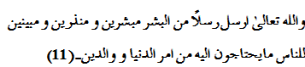
The need for the prophets was justified by the Muhaddith of Delhi by citing the two verses of the Quran:
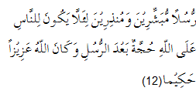
- “Apostles who gave, good news
As well as warning,
That mankind after (the coming)
Of the Apostles, should have
No plea against God:
For God is Exalted in Power, Wise.”
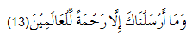
- “We sent you not, but
As a mercy of all creatures.”
The essentials of every field of knowledge known to man, have come to the human being through the offices of Allah’s prophets, because all knowledge springs from the fountainhead of divine revelation. The scholars and thinkers of this world, the Muhaddith of Delhi argues, have all drunk from this fountain for their knowledge; and though they might increase it through analogy, the exercise of the power of judgment, and experimentation, they do no more than to elucidate and interpret what the prophets taught. The Muhaddith of Delhi falsifies the believe that these thinkers and scholars never relied on teachers for their knowledge, and that they depended entirely on their intellect. He declares such claims as extremely far-fetched. ⁽¹⁴⁾
Dogmatically, nothing is incumbent upon the Lord and He is under no obligation or compulsion in any of the things He does; whatever He does is of His own volition and Will. Allah, in His Grace, His Mercy, His Generosity and His Compassion, has taken on Himself the administration of the social and spiritual welfare of mankind. This is where the prophets fit in. Since the great majority of mankind is neither prepared nor able to receive direct communication from Allah, He has selected the prophets to receive knowledge of His person, His attributes, and His ways; and He has taught them the way to man’s success in this world and the next.
- The second argument in favour of the prophethood, as discussed by the Muhaddith of Delhi, is the miracles and clear sign awarded to the prophets by God to substantiate their claims. These are called mʻujizāt.
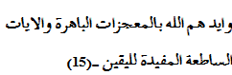
A mʻujizah is anything that does not allow duplication by others and occurs contrary to the ordinary course of affairs at the hands of one who claims to be prophet in apparent support of his claim. The Muhaddith of Delhi says that through the exercise of His power, the Almighty sometimes breaks through the ordinary course of affairs by bringing about at the hands of His prophets, actions and events that have no tangible causes, as evidence of their prophethood.
The mʻujizah is the doing of Allah, and not of the prophets; it constitutes an indisputable proof of a prophet’s truthfulness. The logical proof is nothing more than a few knots in a thread of reasoning, while after a miracle is witnessed, one’s inner being is forced to acknowledge the truth. ⁽¹⁶⁾
- The most excellent of the prophets is Muhammad (peace be on him).
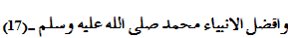
Other prophets performed miracles of two kinds, but the Prophet Muhammad (upon whom be peace) performed miracles of every kind; and he performed a great many of them. Whatever perfections were to be found in the persons of the prophets that passed before him came together as a whole in the person of the last Prophet. In the traditions it is recorded that the Prophet said:

“I would be the chief of Adam’s children on the Day of Judgment.”
In the same tradition, he pronounced:
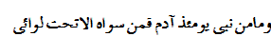
“And there will be no prophet on that Day including Adam and all those after him but would be (united in following me) beneath my banner.” ⁽¹⁹⁾
But the greatest of the Prophet’s miracles is the noble Quran, one of Allah’s attributes, and His glorified eternal word, the Muhaddith of Delhi asserts. ⁽²⁰⁾ And one of the greatest proofs of the Quran’s authenticity is to be found in the challenge the Quran posed to its adversaries, the Quraysh; known for their eloquence and command of Arabic:
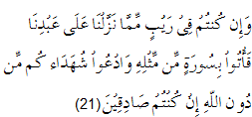

“And if you are in doubt
As to what We have revealed
From time to time to Our servant,
Then produce a Sura
Like thereunto;
And call your witness or helpers
(If there are any) besides God,
If your (doubts) are true.”
And finally the Quran pronounced that it was beyond all the creatures to produce anything similar to this book:
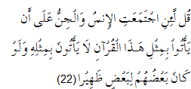

“Say: “If the whole
Of mankind and Jinns
Were to gather together
To produce the like
Of this Quran, they
Could not produce
The like thereof, even if
They back up each other
With help and support.” ⁽¹²⁾
While dealing with the Quran, the greatest miracle, the Muhaddith of Delhi declared the devout conduct, pleasing character, and laudable habits of the last Prophet as an inimitable sign (iʻijāz). He cites the Persian couplets:
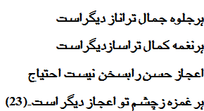
(Every glimpse of your loveliness is another delicacy.
Every song of your perfection is another music.
The wonder of your beauty is in no need of the vocable.
Every blink of your eye is another miracle!)
- The first of the Prophets was Adam, and the last of them was Muhammad (upon whom be the peace of Allah) and it is more appropriate to refrain from specifying their numbers.
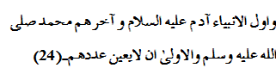
The Muhaddith of Delhi declared the finality of the last Prophet an evidence of his prophethood. When the mission of the Prophet had been accomplished, and both religion and manners had been perfected, there remained no further need for any other prophets. This was pronounced in the Quran:
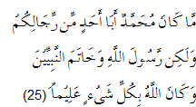

“Muhammad is not
The father of any
Of your men, but (he is)
The Apostle of God,
And the Seal of the Prophets:
And God has full knowledge
Of all things.”
According to learned scholar, the number of the prophets one hundred and twenty four thousand has been mentioned in some traditions. Since the number is not revealed in the Quran, the scholar says, we should not specify their numbers. ⁽²⁶⁾ The Quran is categorically ambiguous in this regard:
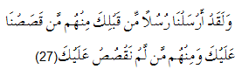

“We did aforetime send
Apostles before you: of them
There are some whose story
We have related to you,
And some whose story
We have not related to you.”
- The prophets were, all of them, Allah’s messengers, truthful, free of sin, and not one of them was removed from office.
To the Muhaddith of Delhi, this innocence and truthfulness of the prophets was another evidence of their prophethood. Whatever the prophets said is true. The information they brought came from Allah and likewise whatever they ordered and whatever they prohibited. Once they established, through miracles or otherwise, the truth of their claims to prophethood, there could be no doubt that what they said was entrusted to them by the Almighty in the form of a message.
If a prophet was to speak an untruth, the wisdom in sending him would have been for naught; and if he committed a sin, people would have found him repulsive. Finally the result would have been that his teaching and advice to them was wasted. The prophets were free, in every way, of untruth and major sins; they could commit them neither purposely nor heedlessly. According to most of the scholars, the Muhaddith of Delhi argues, the prophets were never guilty of having committed a major sin purposely. Some writers say the commission of major sins by mistake, and minor sins purposely, is possible with regard to the prophets. They, however, exempt those sins which are considered repugnant or indicative of vileness on the part of the one who commits them, like the theft of a morsel or of tampering with scales. The entire community of Sunni Muslims is agreed that the prophets are free of both major and minor sins, intentionally committed or inadvertently. The Muhaddith of Delhi clarifies that the prophets were never dismissed from their offices. This position bestowed upon them through the generosity and kindness of the Almighty is not something to be retracted. ⁽²⁹⁾
- The inimitability of the Quran lies in its eloquence and literary styles.
The claim of the Quraysh to be the most eloquent tribe in Arabia was universally recognized. For this reason the Quran was revealed in the very words and letters they claimed to have mastered. Historically speaking, most of the miracles performed by the prophets had occurred in areas judged to be the exclusive domain, and indeed the source of pride, of a certain people, of a certain time; as in the case of magic at the time of Moses (peace be on him), and medicine at the time of Jesus (peace be on him). These people were experts in uncovering the fault of others in their particular fields, and establishing others’ weaknesses, and pointing out the places where they had contradicted themselves.
In the time of the last Prophet, the Muhaddith of Delhi says, the domain of the Arabs was eloquence. Yet, despite of the Quran’s having been revealed in the same letters and words that they themselves took pride in being able to mould into the most lucid and eloquent language, they were unable to produce a single verse to equal it. This is what is known as the iʻijāz of the Quran. The Mutazilities in early Islamic history claimed that they could produce speech similar to the Quran, but the manifest power of the Almighty frustrated them in their designs and put a seal on the lips so that they were unable to produce even a verse to compare with the Quran.
This theory of sarfah as advocated by Mutazilities was declared by the Muhaddith of Delhi as violating to the Quran’s claims. The Muhaddith argued, if we wanted, we could say that our purposes could also be served by imagining for a moment that their claims were legitimate, and then pointing to the fact that in spite of their supposed ability to duplicate such speech, and their extreme avidity in taking up such a challenge, they were thwarted in the attempt. This might also be termed iʻijāz. However, the Mutazilities were irresponsible in their claims and spoke on the basis of nothing more than their own limited faculties of reason, the Muhaddith of Delhi criticises. ⁽³⁰⁾
- The Prophet was sent to all the creatures.
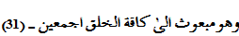
Muhammad (upon whom be peace and blessings of Allah), was sent to men and Jinns alike, and was, therefore, called ‘The Prophet of the Two Weighty Ones’ (Rasul al-Thaqalayn). The Jinns’ visiting the Prophet, their faith in him, their listening to the Quran, and the Prophet’s visiting to them for the purpose of preaching Islam are all mentioned in the Quran. The Quran clearly defined that the Jinns had evidently heard of the previous revelations but were determined to accept, the truth of the Quran and preach the good message of unity:
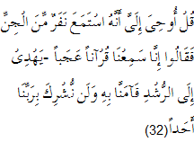

Say: It has been
Revealed to me that
A company of Jinns
Listened (to the Quran).
They said, “we have
Really heard a wonderful recital!
It gives guidance
To the Right,
And we have believed therein:
We shall not join (in worship)
Any (gods) with our Lord.” ⁽²²⁾
Most of the scholars are of the opinion that Muhammad (upon whom be peace) was the only Prophet to be sent to men and Jinns alike. Hafiz Jalaluddin Suyuti (1445-1505 A.D.), however, has written that the Jinns, without doubt, have been legally competent, from the legal point of view, in times of former prophets as well, and one is not legally competent unless he personally hears a prophet, or receives words of him and his Shariah by means of some reliable and truthful transmitter. Furthermore, the scholars are agreed, says the Muhaddith of Delhi, that a Jinn has never been sent as a prophet to his own kind. In the holy Quran it is recorded:
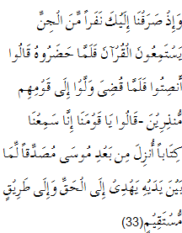

“Behold, we turned
Towards you a company
Of Jinns (quietly) listening
To the Quran: when they
Stood in the presence
Thereof, they said, “Listen
In silence! “When the (reading)
Was finished, they returned
To their people, to warn
(Them of their sins).
They said, “O our people!
We have heard a Book
Revealed after Moses,
Confirming what came
Before ti: it guides (men)
To the Truth and
To a Straight Path.”
These verses reveal that the Jinns believed in Moses (upon whom be peace) and accepted the guidance of his Shariah, the Muhaddith infers from.
- His community is the best of all religious communities.

This is the logical consequences of the Prophet (upon whom be peace), being the best of all the prophets. The Muhaddith of Delhi has quoted the following verse of the Quran to prove his argument:
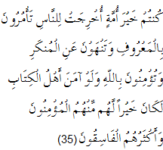

You are the best
Of peoples, evolved
For mankind,
Enjoining what is right,
Forbidding what is wrong,
And believing in God.
If only the People of the Book
Had faith, it were best
For them: among them
Are some who faith,
But most of them
Are perverted transgressors.
The Muhaddith of Delhi cites the traditions of the Prophet to prove the precedence of Muslim community over other communities of the world in order to justify the finality of the prophethood of Muhammad (upon whom be peace). The traditions record that the age of this Ummah in comparison with the previous communities is as the time from ʻAsr (mid-afternoon) to Maghrib (sunset) in relation to the remainder of the day. In spite of its relatively short duration, it, however, will receive a much greater reward. ⁽³⁶⁾
In the same tradition, the Prophet of Islam (upon whom be peace) explained to his companions that the likeness of his Ummah in relation to the Christians and the Jews would become apparent to them through the story of an employer who hired three men. The first to work for him from dawn to noon and receive a wage of one dirham. The second was to work for him from noon to mid-afternoon and receive a wage of one dirham. The third’s wage was set at two dirham’s for working from mid-afternoon to sundown. When the time came for payment, the first two men received a dirham each and the third received his two dirhams. When the first two saw the difference in their wages they became angry and began arguing with their employer. They hard worked longer, they complained, and received less while the other worked less and received more. The employer told them that he had only given them the wages he had fixed for them. “The rest”, he said, “has to do with my generosity and I will spend it where I will.” The first worker in story represented the Jews, the second worker the Christians, and the third the people of this Ummah. ⁽³⁷⁾
While this is the last Ummah in time, concludes the Muhaddith of Delhi, it is the first in reward. Indeed, innumerable traditions have come to us about the virtues of this Ummah. Without a doubt, the wonderful and strange contributions, the knowledge, the acquirements and spiritual accomplishment exhibited by this community have never been equalled by any other community of the world. ⁽³⁸⁾
- His Shariah is the most perfect of all revealed legal systems and Islam is the religion that abrogates all others.

Since Muhammad (upon whom be peace) was the “seal” and the last of the prophets, there remains no possibility for any other Shariah or religion to emerge in future. The Prophet himself is reported to have declared:

(I was sent to perfect the most laudable of character qualities.)
The Shariah of Moses (upon whom be peace) was characterized by its strict and even vengeful aspects, elaborates the Muhaddith of Delhi. For example, the way to repentance was suicide; a great number of foods permissible in Muslims’ law were for them forbidden; they were checked from sharing the spoils of war; and they were subject to almost immediate divine punishment when they erred. Moses (upon whom be peace) himself commanded a great deal of fearful reverence. His fury and his severity in dealing with the enemies of faith was such that not even his co-religionists dared to look him in the eye.
The Prophet Jesus (upon whom be peace) was the model of love and kindness. His Shariah was so characterized by leniency and grace that it contained no legislation concerning the prosecution of battles or punishments, rather it prohibited outright the making of war. The Muhaddith of Delhi cited Mathew 5:29-30 to prove his argument:
“But I say unto you, that ye resist not evil: but who shall smite thee on thy right cheek, turn to him the other also, and if any man will sue thee at the law, and take away thy coat, let him have thy cloak also, and whosoever shall compel thee to go a mile, go with him twain.” ⁽⁴¹⁾

Traditional Approach
This is a description precisely of the evidences of the prophethood made in Takmil al-Imān by Shaykh Abdul Haqq, the Muhaddith of Delhi. It is rightly claimed by Khaliq Ahmad Nizami that the entire writing of the Muhaddith aimed at responding academically to the so-called rationalism prevailed India under Akbar, the Great. The Muhaddith, therefore, reacted sharply against any key-role of the reason in the matters of religion, and provided with strong arguments and clear evidences in support of prophethood. His aggressive approach to philosophy and kalam should be seen in this perspective. The comparison between philosophy and religion and delimiting the role of first in the matter of the latter is evident in his writings. In Marj al-Bahrayn, one of his works, he cautions readers to involves in philosophy:
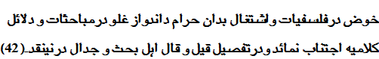
The mere reason puts a man in suspicion and surprise and does not resolve the problems of life. This contains the elements of misguidance and destruction and does not inherit at all the capabilities of construction and development, and therefore its limits are to be defined necessarily:
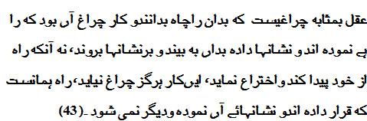
Prof. Nizami has rightly advocated the delimiting of the role of reason in revelation since it does not suffice the construction of human individual and society. ⁽⁴⁴⁾ The case of Shaykh Bediuzzaaman Said Nursi is entirely different. He has thoroughly discussed the evidences of prophethood in Risale-i-Nur but in a different style.

Nursi’s Risale-i Nur
Evidences of the prophethood, as discussed in the Nineteenth Word of the Risale-i Nur are fourteen in number and constitute the highly sophisticated arguments produced so far by the Muslim theologians and scholastic scholars in the field. Shaykh Nursi believed that he could not praise Muhammad (upon whom be peace) with his words; rather his words were made praiseworthy by the Prophet. This word is beautiful, but what make it so is the most beautiful of all things, the attributes and qualities of Muhammad (peace be on him).” ⁽⁴⁵⁾
In the second station of the fourteenth flashes in The Words, Shaykh Nursi elaborates the six mysteries of the following verses of the Quran:
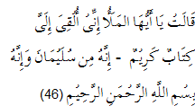
(The Queen) said: “Ye chiefs!
Here is-delivered to me-
A letter worthy of respect.
“It is from Solomon, and is
(As follows): “In the name
Of God, the Merciful,
The compassionate.”
Shaykh Nursi exposes, in the sixth mystery of the Quranic words: “In the name of God, the Merciful, and the compassionate the mercy of Almighty, which is inaccessable to man directly. This mercy may be attained through a sincere following of the Prophet (upon whom be peace) who was entitled in the Quran as “Mercy for all creatures.” ⁽⁴⁷⁾ Nursi addresses the human being to improve his soul inorder to reach a higher level of purification and spirituality by loving affectionately and following selflessly the way of the Prophet:
“That is Divine Mercy for you, O man! It raises you to be presence of the One absolutely lacking any need, the Eternal Sovereign, and makes you His friend, addressee, and well-loved servant. But just as you can not reach the sun, are far from it and can in no way draw close to it, although the sun’s light gives you its reflection and manifestation by mean of your mirror, in the same way are infinitely distant from the Most Pure and Holy One, the sun of Pre-Eternity and Post-Eternity, and cannot draw close to Him, but the light of His Mercy makes Him closer to us.
“And so O man! He who finds this Mercy finds an eternal unfailing treasury of light. And the way to find it is through following the Practices of the Most Noble Prophet (upon whom be blessings and peace), who has the most brilliant exemplar and representative of Mercy, its most eloquent tongue and herald, and was described in the Quran as a “Mercy to all the worlds.”
“And the means to this embodiment of Mercy who is a Mercy to All the worlds is to utter the prayer calling down God’s blessings upon him. Indeed, the meaning of this prayer is Mercy. As a prayer of Mercy for that living embodiment of Divine Mercy, it is the means of reaching the Mercy to All the Worlds. So make this prayer the means to Mercy to All the Worlds for yourself, and at the same time make him the means to Mercy of the Most Merciful.” ⁽⁴⁸⁾
The Nineteenth Word of the Risale-i Nur, elaborating the evidences of the prophethood consists of fourteen ‘Droplets’:
- Universality of Messengership
Nursi discussed the universal character of the messengership of Muhammad (upon whom be peace and blessings), for whom the face of the earth was made his mosque, Makkah his mihrāb, and Madinah his pulpit. He was the leader of all the believers, preacher to all mankind, the chief of all the prophets, Lord of all the saints, the leader of a circle for the remembrance of God comprising all the prophets and saints. The Prophet is a luminous tree whose living roots are all the prophets, and fresh fruits are all the saints; whose claims all the prophets relying on their miracles and all the saints relying on their wonder-working confirm and corroborate. This first droplet of the Nineteenth Word is testified by the Quran and the traditions of the Prophet:
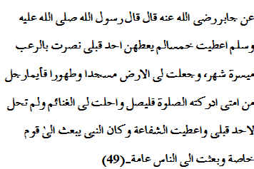
Jabir narrates that the Messenger fo God is reported to have said: “I am awarded five things which were not awarded to anyone before: I am supported with the terror on the enemies living with in the destination of one month’s travel; the entire earth is made mosque and clean for me, so anyone from my community should perform prayer anywhere at the time; the booty is made permissible for me while it was forbidden for others; I am entitled to intercession at the Last Day; and the apostles were used to be sent specific to some nations but I am deputed as messenger of God to the whole mankind.”
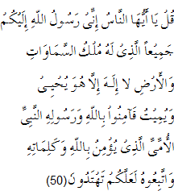

“Say: O men! I am sent
Unto you all, as the Apostle
Of God, to whom belongs
The dominion of the heavens
And the earth: there is no god
But He: it is He that gives
Both life and death. So believe
In God and His Apostle,
The Unlettered Prophet,
Who believes in God
And His words: follow him
That (so)you may be guided.”
- Miracles and Scriptures’ Narrations
Shaykh Nursi emphasizes on the hundreds of indications in the revealed scriptures like the Torah and Bible as a clear proof for the messengership of the Last Prophet. ⁽⁵¹⁾ The well-known news given by the voices from the Unseen and the unanimous testimony of the soothsayers, the indications of thousands of his miracles like the splitting of the Moon, and the justice of Shariah all confirm and corroborate him. The Quran has clearly defined this droplet:
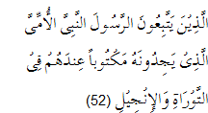
Those who follow the Apostle,
The unlettered Prophet,
Whom they find mentioned
In their own (Scriptures),
In the Torah and the Gospel.”
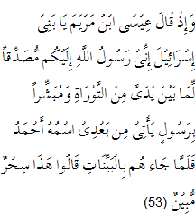
And remember, Jesus,
The son of Mary, said:
“O children of Israel!
I am the apostle of God
(Sent) to you, confirming
The Torah (which came)
Before me, and giving
Glad Tiding of an Apostle
To come after me,
Whose name shall be Ahmad.”
But when he came to them
With Clear Signs,
They said, “This is
Evident sorcery!”
- Fine Character and Beautiful Form
Shaykh Nursi discussed the truthfulness and honesty of the Prophet as the third droplet to prove the prophethood. A person distinguished by his fine character and beautiful form, in whose hand is a miraculous book, and on whose tongue is a truthful address, cannot be an impostor. Muhammad (peace be on him) lived his whole life of purity and virtue amongst his people, and they knew and acknowledged it before he received his mission. They knew he loved his nation and was loyal to it. The Quran has narrated this as a clear proof for his messengership:
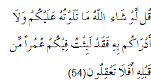
Say: “If God had so willed,
I should not have rehearsed it
To you, nor would He
Have made it known to you.
A whole life-time before this
Have I tarried amongst you:
Will you not then understand?”

- Harmony and Coordination in the Universe
To Nursi, if the universe is to be looked at as being outside the luminous sphere of the truth and guidance the Prophet provided us, we see it to be like a place of general mourning, and beings strangers to one another and hostile, and inanimate being to be likely ghastly corpses and living creatures like orphans weeping at the blows of death and separation. But the Quran gave us a light to see the universe in coordination and harmony, where God’s Names and praises are recited in joy and ecstasy. ⁽⁵⁵⁾ The foreign-hostile beings have become friends and brothers. The Quran terms it tasbih:
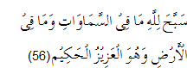
Whatever is
In the heavens and
On earth, let it declare
The Praise and Glory
Of God: for He is
The Exalted in Might,
The Wise.
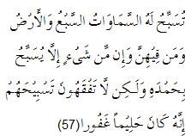
The seven heavens and the earth,
And all beings there in,
Declare His glory:
There is not a thing
But celebrates His praise;
And yet you understand not
How they declare His glory!
Verily He is Oft-Forbearing,
Most forgiving!
- Man Being a Petted Monarch
Through the light provided with by the Prophet (peace be on him) the world becomes a book of the Eternally Besought One’s wisdom, and man illuminated with that light rises above all animals and all creatures. Through entreaty, his illuminated impotence, poverty, and intelligence make him a petted monarch; due to his complaints, he becomes a spoiled vicegerent of the earth. ⁽⁵⁸⁾ This was masterly portrayed in the Quran:
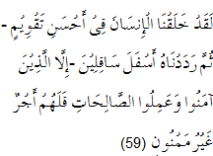
We have indeed created man
In the best of moulds,
Then do We abase him
(To be) the lowest
Of the low,
Except such as believe
And do righteous deeds:
For they shall have
A reward unfailing.
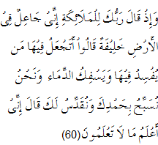
Behold, your Lord said to the angels:
“I will create a vicegerent on earth.”
They said:
“Will you place therein one who will make
Mischief therein and shed blood?”-
While we do celebrate Your praises
And glorify your holy (name)?”
He said: “I know what you know not.”
- Exemplar of Mercy
Muhammad (upon whom be peace and blessings) is certainly seen as the model of love, the exemplar of mercy, the glory of mankind, and the most luminous fruit of the tree of creation, if regarded to be a worshipful servant of God. But if he is seen as the messenger of God, he will be surely found to be the proof of God, the lamp of truth, the sun of guidance, and the means to happiness, Nursi describes the two positions as the proof of the prophethood. ⁽⁶¹⁾ The Quran has defined each of the positions of the Prophet in order to prove his authenticity:
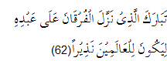
Blessed is He who
Sent down the Criterion
To His servant, that it
May be an admonition
To all creatures.
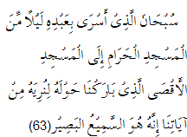
Glory to (God)
Who did take His Servant
For a Journey by night
From the Sacred Mosque
To the farthest Mosque,
Whose precincts We did
Bliss-in order that We
Might show him some
Of Our Signs: for He
Is the one who hears
And sees (all things).
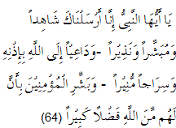
O Prophet! Truly We
Have sent you as
A witness, a Bearer
Of Glad Tidings,
And a Warner,
And as one who invites
To God’s (Grace) by His leave,
And as a lamp
Spreading Light.
Then give the glad tidings
To the Believers, that
They shall have from God
A very great bounty.
- Inward Revolution
As the seventh droplet of the Nineteenth Word, Nursi highlighted the nature and consequences of the revolution the Prophet brought by his mission and unmatched personality. The Prophet of Islam, by eradicating in no time at all their evil, savage customs and habits to which Arabs were fanatically attached, decked out the various wild, unyielding peoples of that broad peninsula with all the finest virtues, and make them teachers of all the world and masters to the civilized nations. The Prophet conquered and subjugated their minds, spirits, hearts and souls. He became the beloved of hearts, the teacher of minds, the trainer of souls and the ruler of spirits. The Quran appreciated this unmatched quality of the Prophet and acknowledged this unique revolution:
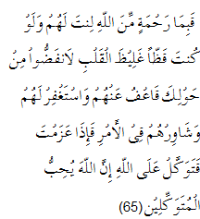
It is part of the Mercy
Of God that you do deal
Gently with them.
Were you severe
Or harsh-hearted,
They would have broken away
From about you: so pass over
(Their faults), and ask
For (God’s) forgiveness
For them; and consult
Them in affairs (of moment).
Then, when you have
Taken a decision,
Put your trust in God.
For God loves those
Who put their trust (in Him).
- Arabian Peninsula-A Model
Said Nursi presented the Arabian Peninsula as a challenge to those who refuse to see the testimony of the blessed age of the Prophet. The Prophet removed ingrained habits from intractable, fanatical large nations with slight outward power and little effort in a short period of time, and in their place he so established exalted qualities that they became as firm as if they had mingled with their very blood. ⁽⁶⁶⁾ The Quran reminded the Arabs the pre-Islamic state of affairs, the civil and tribal feuds and dissensions and that how Yathrib turned after the advent of Islam into the city of unmatched brotherhood:
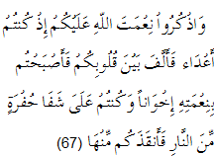
And remember with gratitude
God’s favour on you;
For you were enemies
And He joined your hearts
In love, so that by His Grace,
You became brethren;
And you were on the brink
Of the Pit of Fire,
And He saved you from it.

- No Contradiction in the Character
Another evidence of prophethood of Muhammad (upon whom be peace) is the integrity and truthfulness he exhibited throughout his life. Although the Prophet undertook a tremendous task which required an official of great authority and great standing and a situation of great security, but no contradiction at all could be found in the words he uttered among a community of great size in the face of great hostility concerning a great cause and matters of great significance. The Quran noticed this point and denounced any sort of contradiction in the life of the prophets:
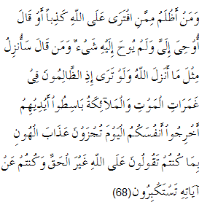
Who can be more wicked
Than one who invents
A lie against God,
Or says, “I have
Received inspiration”,
When he was received
None, or (again) who says,
“I can reveal the like
Of God has revealed?”
If you could but see
How the wicked (do fare)
In the flood of confusion
At death!- the angels
Stretch forth their hands,
(Saying), “Yield up your souls:
This day shall you receive
Your reward,- a penalty
Of same, for that you used
To tell lies against God,
And scornfully to reject
Of His Signs!”
- Predictions of Doom’s Day
The Prophet showed the truths that were curiosity-arousing, attractive, necessary and awesome. He told of a Monarch who is such that in His realm, the Moon flies round a moth like a fly, and the moth, the earth, flutters round a lamp, and the lamp, the sun, is merely one lamp among thousands in one guest-house out of thousands of that Monarch. The Prophet spoke truly of a world so wondrous and revolution that is such that if the earth was a bomb and exploded it would not be all that strange.
Said Nursi says that curiosity impels man the most. Even, if it was to be said to you:”If you give half of your life and property, someone will come from the Moon and Jupiter and tell you all about them. He will also tell you the truth about your future and what will happen to you”, and would be bound to give them if you have any curiosity at all. ⁽⁶⁹⁾ Nursi has cited the Quranic chapters like Surah al-Takwīr, Surah al-Infitār, Surah al-Qāriʻah to prove the curiosity-arousing and instigating nature of the predictions of Doom’s Day. This tenth droplet of the Nineteenth Word constitutes another proof of the prophethood of Muhammad. This miraculous point of the Quran’s inimitability was alter theorized masterly by Sayyid Qutb (1906-1966) in his reputed books like Al-Taswīr al-Fanni fi al-Quran and Mashāhid al-Qiyāmah fi al-Quran. ⁽⁷⁰⁾ Recite for example the following verses:
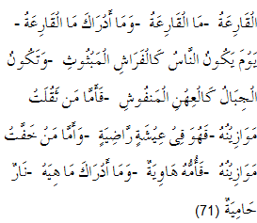
The Day of
Noise and Clamour:
What is the (Day)
Of Noise and Clamour?
And what will explain
To you what the (Day)
Of Noise and Clamour is?
(It is) a Day whereon
Men will be like moths
Scattered about,
And the mountains
Will be like carded wool.
Then, he whose
Balance (of good deeds)
Will be (found) heavy,
Will be in a life
Of good pleasure and satisfaction.
But he whose
Balance of (good deeds)
Will be (found) light,-
Will have his home
In a (bottomless) Pit.
And what will explain
To you what this is?
(It is) a Fire
Blazing fiercely!
- Exposing Wonders of the Universe
For sure, wonders await us under the apparent veil of the universe which is thus strange and perplexing, says Said Nursi in the eleventh droplet of the Nineteenth Word. So one thus wonderful and extraordinary, a displayer of marvels, is necessary to tell of its wonders. It is apparent from the Prophet’s conduct that he has seen them, and sees them, and says that he has seen them. ⁽⁷²⁾ The Quran certifies this:
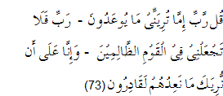
Say: “O my Lord!
If you will show me
(In my life time) that which
They are warned against,-
“Then O my Lord! Put me not
Amongst the people
Who do wrong!”
And we are certainly able
To show you (in fulfilment)
That against which they are warned.
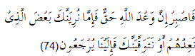
So, preserve in patience;
For the Promise of God
Is true: and whether
We show you (in this life)
Some part of what We
Promise them,- or We
Take your soul (to our Mercy)
(Before that),- (in any case)
It is to Us that
They shall (all) return.
- Guide for Eternal Happiness
The twelfth droplet of the Nineteenth Word deals with the Prophet of Islam as the guide and source for eternal happiness. He is a decisive proof and clear evidence for the resurrection of the dead and divine rewards. With his guidance he is the reason for and means of attaining the everlasting happiness; so too through his prayers and supplications, he is the cause of its existence and reason for its creation. ⁽⁷⁵⁾ The Quran portrays the state of righteous people in the Day of Judgment, their entrance in the Gardens in crowd, theirs receiving greetings with the salutation of peace from the angels in heaven, and their expression of satisfaction and gratitude in extempore in the following verses:
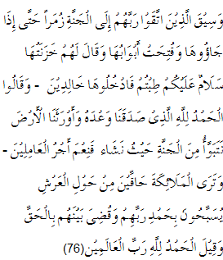
And those who feared
Their Lord will be led
To the Garden in crowds:
Until behold, they arrive there;
Its gates will be opened;
And its keepers will say:
“Peace be upon you!
Well have you done!
Enter you here,
To dwell therein.”
They will say: “Praise be
To God, who has
Truly fulfilled His promise
To us, and has given us
(This) land in heritage:
We can dwell in the Garden
As we will: how excellent
A reward for those
Who work (righteousness)!”
And you will see
The angels surrounding
The Throne (Divine)
On all sides, singing Glory
And Praise to their Lord.
The decision between them
(At Judgment) will be
In (perfect) justice,
And the cry (on all sides)
Will be, “Praise be to God,
The Lords of the worlds!”
- His worship of God,Reason to the Next World
This droplet of the Nineteenth Word explains how does the Prophet of Islam being the source and guide to eternal happiness, pray to meet with God, observe all His Divine Names and enter the Paradise. Even, if it were not for reasons for the fulfillment of those countless requests, like mercy, grace, wisdom and justice, a single of that Being’s prayers would have been sufficient for the construction of Paradise, the creation of which is as easy for Divine power as the creation of the spring. Said Nursi argues that just as the messengership of the Prophet was the reason for the opening of this place of examination and trial, so too is his worship and servitude to God were the reason for the opening of the next world. ⁽⁷⁷⁾ See and recite the following beautiful verses:
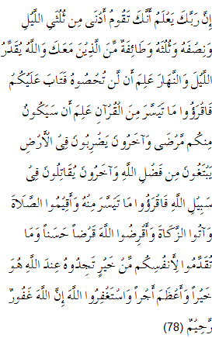
Your Lord does know
That you stand forth
(To prayer) nigh two-thirds
Of the night, or half
The night, or a third
Of the night, and so does
A pary of those with you.
But God does appoint Night
And Day in due measure.
He knows that you are
Unable to keep count thereof.
So He has turned to you
(In mercy): read you,
Therefore, of the Quran
As much as may be
Easy for you. He knows
That there may be (some)
Among you in ill-health;
Others travelling through the land,
Seeking of God’s bounty;
Yet others fighting
In God’s cause. Read you
Therefore, as much of the Quran
As may be easy (for you);
And establish regular Prayer
And give regular Charity;
And loan to God
A Beautiful Loan.
And whatever good
You send forth
For your souls,
You shall find it
In God’s Presence,-
Yea, better and
Greater, in Reward.
And seek you the Grace
Of God: for God is
Oft-Forgiving, Most Merciful.
- Miraculousness of the Quran
The All-Wise Quran, the treasury of miracles and supreme miracle, proves the prophethood of Muhammad (peace be on him) together with Divine unity so decisively that it leaves no need for further proof, asserts Bediuzzaman Said Nursi. To him:
“The All-Wise Quran, which makes known to us our Sustainer, is thus: it is the pre-eternal translator of the great book of the universe; the discloser of the treasures of the Divine Names concealed in the pages of the earth and the heavens; the key to the truths hidden beneath these lines of events; the treasury of the favours of the Most Merciful and pre-eternal addresses, which come forth from the World of the Unseen beyond the veil of this Manifest world; the sun, foundation, and plan of the spiritual world of Islam, and the map of the worlds of the hereafter; the distinct expounder, lucid exposition, articulate proof, and clear translator of the Divine Essence, attributes, and deeds; the instructor, true wisdom, guide, and leader of the world of humanity; it is both a book of wisdom and law, and a book of prayer and worship, and a book of command and summons, and a book of invocation and Divine knowledge-it is book for all spiritual needs; and it is a sacred library offering books appropriate to the ways of all the saints and veracious, the purified and the scholars, whose ways and paths are all different.” ⁽⁷⁹⁾
Repetition in the Quran (takrār) is considered to be a fault, says Said Nursi, but the flashes of miraculousness in it are to be considered. “The repetition of verses arises from the repetition of need. It makes the repetition in order to point out the need and awaken and incite it, and to arouse desire and appetite.” ⁽⁸⁰⁾ Nursi has discussed the following rationale for the repetition in the Quran:
- The Quran is both a book of invocation, a book of prayer and a book of summons. The mark of invocation is illumination through repetition. The mark of prayer is strengthening through repetition. The mark of command and summons is confirmation through repetition.
- Everyone is not capable of always reading the whole Quran, but is mostly able to read one Surah. Since most of the objectives and teachings of the Quran are included in most of the longer Surahs, each is likely a small Quran. In order to provide an opportunity to recite the Quran to everyone certain aims, objects and stories were repeated.
- Like bodily needs, spiritual needs are various. Man is in need of some of them in every breath, like spirit needs “He” every time and this requires a repetition.
- The Quran is a founder and a basis for the clear Religion. It changed human social life and is the answer to the repeated questions of its various classes.
- The Quran speaks of such mighty matters and minute truths that numerous repetitions are necessary in different forms in order to establish them in everyone’s hearts. ⁽⁸¹⁾
These theological and scholastic dimensions of the rationale of repetition in the Quran were to some extent an addition to what was elaborated by the Quranic scholars in the field. Al-Muʻallim Abdul Hameed (known better as Hameeduddin) al-Farāhi (1863-1930 A.D.), a prominent scholar of modern India and writer of Tafsir Nizām al-Quran, had discussed in Arabic language the repetition in the Quran (takrār) a literary style frequently used in pre-Islamic Arabic poetry. ⁽⁸²⁾

Conclusion
Both the Takmil al-Imān of Shaykh Abdul Haqq, the Muhaddith of Delhi, and Risale-i Nur of Shaykh Bediuzzaman Said Nursi confronted the religious heresies of the time and were composed in response to the intellectual challenges posed by those in power and authority and nullified academically the anti-religious arguments and provided with solid and sound evidences of the prophethood of Muhammad (peace be on him). Apart from Shaykh Ahmad Sirhindi (1564-1624) who launched a strong revivalist movement against the heresies of Akbar, the Great Mughal ruler through his writings, letters and dynamism, Shaykh Abdul Haqq, the Muhaddith of Delhi responded to the same issues academically but in his own fashion different from his contemporary sufi scholar. Nursi too confronted in Turkey with the heresies of Mustafa Kamal Ataturk (1881-1938). His role as a revivalist in his first phase of life, known as ‘Old Said’, was closer to that of the Mujaddid Alf Thani Shaykh Ahmad Sirhindi, from whom he was, inspired the most. His role in the second phase, known as ‘New Said’, was however nearer to that of Shaykh Abdul Haqq, the Muhaddith of Delhi. Both the works Takmīl al-Imān and Risale-i Nur consisted of the deliberations on Islamic belief and contained the evidences of the prophethood, its rationale and arguments.
The approach and method adopted by the two scholars were, however, different: the Muhaddith of Delhi followed a traditional line and mainly based his arguments on the sources of hadith, fiqh and Quran. Nursi’s approach is scientific and he relied essentially on the Quran and sought some support from modern knowledge. The first opposed fiercely the philosophy and ilm al-kalam and considered them as misleading, while the latter was an Islamic theologian who always considered the science and philosophy as conciliatory to religion. Both were different in their mystic and esoteric interpretations too. The Muhaddith of Delhi advocated, interpreted and defended Shaykh Abdul Qadri Jilāni (1077/78-1166 AD) while the Turkish theologian and reformer followed the thought of Shaykh Ahmad Sirhindi and the Naqshbandiyah order in his writings. The first adopted Persian language to compose Takmīl al-Imān and cited a number of Persian poetic couplets to prove his arguments, while the latter wrote in Turlish and sometimes in Arabic and avoided any poetic style in his works; he rather preferred the scientific and rational style and had a direct access to the mind of the reader.

Notes and References
- The Quran, 4:69.
- The Quran, 5:50.
- The Quran, 72:27-28.
- The Quran, 23:51.
- The Quran, 27:10.
- The Quran, 61:6.
- The Quran, 4:174.
- Nizami, Khaliq Ahmad, Hayat Shaykh Abdul Haqq Muhaddith Dehlwi, Delhi, Nadwatul Mussanifin, September 1953, pp. 159-160.
- The Encyclopaedia of Islam, New Edition, 1960, vol.1, pp. 60-61.
- Abdul Haqq, Shaykh (The Muhaddith of Delhi), The Perfection of Faith and its Commentary The Fortification of Conviction, Islamabad (Pakistan), Islamic Research Institute, International Islamic University, 1406/1986, The Author’s Introduction.
- Ibid., p.63.
- The Quran 4:165.
- The Quran 21:107.
- The Perfection of Faith, op.cit., pp.63-65.
- Ibid., p.64.
- Ibid., pp. 64-65.
- Ibid., p.72.
- Tirmidi, Abu Isa, Al-Sunan, Kitab al-Manāqib, No.3624.
- The two parts of the same tradition are mistakenly quoted as the two different traditions. Interestingly both the translators (the Urdu and English versions) could not find out this fault. The full text of the hadith reads:
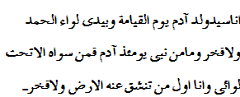
- The Perfection of Faith, op.cit., p.72.
- The Quran, 2:23.
- The Quran, 17:88.
- The Perfection of Faith, op.cit., p.74.
- Ibid., p.65.
- The Quran 33:40.
- The Perfection of Faith, op.cit., p.66.
- The Quran, 40:78.
- The Perfection of Faith, op.cit., p.69.
- Ibid., p.70.
- Ibid., pp. 72-73.
- Ibid., p.74.
- The Quran., 72:1-2.
- The Quran, 46:29-30.
- The Perfection of Faith, op.cit., p.77.
- The Quran, 3:110. The logical conclusion to the evolution of religious history is a non-sectarian, non-racial, non-doctrinal, universal religion, which Islam claims to be. For Islam is just submission to the will of God. This implies (1) Faith, (2) doing right, being an examples to others to do right, and having the power to see that the right prevails, (3) eschewing wrong, being an example to others to eschew wrong, and having the power to see that wrong and injustice are defeated. Islam therefore lives, not for itself, but for mankind. The People of the Book, if only they had faith, would be Muslims, for they have been prepared for Islam. Unfortunately there is Unfaith, but it can never harm those who carry the banner of Faith and Right, which must always be victorious. Yusuf Ali, A. The Holy Quran-Text, Translation and Commentary, 1983, Amana Corp. Maryland, USA. p.151. foot note 434.
- Tirmidi, Abu i̒sa, Al-Sunan, Kitab al-Adab, Bab mā Jaāa fi mithl Ibn Adam wa ajalihi wa amalihi, No.2876.
- The text of the hadith in full reads:
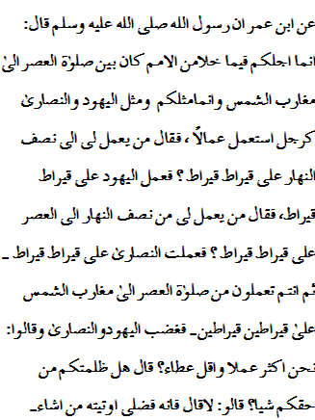
- The Perfection of Faith, op.cit., pp. 77-78.
- Ibid., p.78.
- Imam Malik bin Anas, Kitab al-Muwatta, bab Husn al-Khulq, No.1742, has cited the hadith with a minor difference in the words as follows:
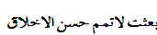
Imam Bukhari, Muhammad bin Ismail, al-Jami al-Sahih, bab Manāqib al-Ansār, No.22; and bab al-Adab, No.39, and Imam Muslim bin al-Hajjāj, Al-Jami al-Sahih, bab Fadāil al-Sahābah, No. 133 have differently cited it as follows:
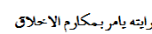
- Maulana Muhammad Anzar Shah Kashmiri son of Sayyid Anwar Shah Kashmiri, the translator of Takmil al-Imān in Urdu, has supported this statement of the Muhaddith of Delhi in his Urdu title Imān Keya Hai, Deoband, Kutubkhana Qasmi, Muharram 1384/May 1984, pp. 184-185, and has added that the Islamic Shariah combined the both: it constituted the strict and vengeful aspects of the law of Moses (upon whom be peace) as well as the grace, love and kindness of the law of Jesus (upon whom be peace). The Islamic Shariah represented the power and might and the softness and lenience as well; it constituted both the silky and irony attributes. The following tradition implied both the laughters and sorrows:
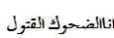
Maulana Kashmiri cited a Persian couplet saying:
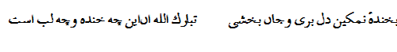
(A salty smile burnt the heart and awarded the life!
Excellent! How is the smile and how are these lips!)
To Maulana Kashmiri, the Quranic verse no 157 from the 7th chapter that reads:
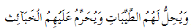
And he allows them what is good (and pure)
And prohibits them from what is bad (and impure)
also communicates the compact and concise nature of Islamic law. If you go through the life, commandments and Shariah of the last Prophet in detail, you would be fully aware of this balanced approach of Islam.
The English rendering of Takmil al-Imān ( The Perfection of Faith, op.cit., p. 79) contains an important note that has clarified some misunderstanding in this regard. The note reads that the Muhaddith of Delhi has made use here of a theory popular among the classical commentators of the Quran. While the Shariah of Islam is, no doubt, the golden mean; that does not necessitate either the severity attributed to the Shariah of Moses or the leniency attributed to the Shariah of Jesus. If Shaykh Abdul Haqq, the Muhaddith of Delhi had looked into Mathew itself, he would have noticed only a few lines above the place that he quoted from, the following verses:
“29: and if thy right eye offend thee, pluck it out, and cast it from thee for it is profitable for thee that one of thy members should perish and not thy whole body should be cast into hell. 30: and if thy right hand should offend thee, cut it off, and cast it from thee: for it is profitable for thee that one of thy members should perish and not that thy whole body should be cast into hell”. Mathew 5: 29-30
According to the notes added in the English rendering, the text quoted above contains two commands, ‘pluck it out’ and ‘cut it out’. The general rule is that a command signifies obligations. However, each of the commands is followed by the words “it is profitable for thee” and not ‘it is obligatory upon thee’. Then, at the very least, this legislation points out the recommended course of a action in such a situation, if not the obligatory rulings. Then, if the Gospel is correct in relating these words, we can see the Shariah of Jesus had its share of severity as well. The incredible thing is that Christians have the audacity to condemn both the practice and principles behind Islamic Law, when the “Christian ethics” they supposedly base their culture on include such concepts as are mentioned in this verse of the Gospel according to Mathew.
- Abdul Haqq, Shaykh Marj al-Bahrayn fi al-Jamʻa bayn al-Tariqayn, p.17.
- Ibid., p.20.
- Nizami, Khaliq Ahmad, op.cit., pp. 289-90. He has cited Muhammad Iqbal (1877- 1938) the Islamic thinker and philosopher who also has defined the reason as chiragh-e-rāh (street lamp) and not as the destination itself. Iqbal says:
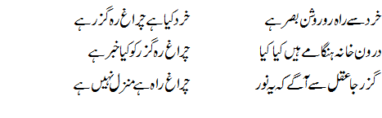
- Nursi, Bediuzzaman Said, The Words (From the Risale-i Nur Collection), translated from Turkish by Sukran Vahide, Ihlas Nur Nesriyat, Ankara 2001, p.244.
- The Quran, 27: 29-30.
- The Quran, 21: 107.
- The Words, op.cit., pp. 25-26. To conclude, Nursi says, “Just as the most precious jewel in the treasury of Mercy and its doorkeeper is the Prophet Muhammad (upon whom be blessings and peace), so too is its first key In the Name of God, the Merciful, the Compassionate. And its most easy kee the prayer for the Prophet”. The concluding prayer of this chapter is too meaningful and reveals this meaning clearly. Nursi says:
“O God! Through the truth of ‘In the Name of God, the Merciful, the Compassionate’ grant blessings and peace to the one whom you sent as a mercy to all the worlds as benefits Your Mercy, and in veneration of him, and to all his Family and Companions. And grant us Mercy so as to make us free of want for the mercy of another than You from among Your creatures. Ameen!” Ibid., p.26.
- Bukhari, Muhammad bin Ismail, Al-Jami al-Sahih, Kitab al-Salah, bab qaul al-nabi juʻilat li al-ardu masjidan wa tahuran, vol.1, No 113.
- The Quran, 7:158.
- In his Risale-i Hamidiye, Husayn Jisri extracted one hundred and fourteen indications from those scriptures. If this may have remained after the texts have become corrupted, there were surely many explicit mentions before.
- The Quran, 7:157.
- The Quran, 61:6.
- The Quran, 10:16.
- The Word, op.cit., p.245.
- The Quran, 61:1.
- The Quran, 17:44.
- The Word, op.cit., p.246.
- The Quran, 95: 4-6.
- The Quran, 2:30.
- The Word, op.cit., p.246.
- The Quran, 25:1.
- The Quran, 17:1.
- The Quran, 33: 45-47.
- The Quran, 3:159.
- The Word, op.cit., p.247.
- The Quran, 3:103.
- The Quran, 6:93.
- The Word, op.cit., pp.247-248.
- The first book Al-Taswīr (The Artistic Portraiture in the Quran) was serially published in al-Muqtataf, a popular magazine in Egypt, in 1939. After having completed the book Sayyid Qutb realized the Quran was taking a new birth in his soul. Previously too, the Quran, to him, was attractive and beautiful; its beauty and charm was, however, in isolation and in the scattered form. After having compiled this book he found the entire Quran a unified entity based on well-balanced, coherent, well-ordered system he never dreamed before nor any other scholar ever imagined. (Qutb, Sayyid, Al-Taswir al-Fanni fi al-Quran, Egypt, Dar al-Maʻārif, 3rd ed. pp. 9-10.) The second book Mashāhid al-Qiyāmah fi al-Quran (The Visible Scenes of the Doom’s Day in the Quran) was written to state the literary beauty and artistic portraiture of the Quran. The author has collected all the 150 visible and living scenes of the Doom’s Day narrated skillfully in the Quran while elaborating the different stages and ranks of the divine rewards and punishments in a dynamic sensible and visible fashion. The Quranic portraiture (taswīr) is one of the characteristics of its literary styles, and is the best medium to communicate skillfully the Quranic worldview. Through the taswir, the secret, hidden or implied objects as well as the inner feelings and the state of emotions are described in the tangible form as well as the generally observable events, spectacles, the human physiques and natures are portrayed so skillfully that a primordial or imaginary idea turns into a dynamic and structured form; the emotions are shaped with sensuous objects; a dead body retreats moving and speaking and the human nature assumes a corporal form. Ibid., p.34.
- The Quran, 101: 1-11.
- The Word, op.cit., p.248.
- The Quran, 23: 93-95.
- The Quran, 40:77.
- The Word, op.cit., pp. 248-249.
- The Quran, 39: 73-75.
- The Word, op.cit., p.249.
- The Quran, 73:20.
- The Word, op.cit., p.251.
- Ibid., p.252.
- Ibid., p.252.
- Al-Farahi, Al-Maʻullim Abdul Hameed, Asālīb al-Quran, Azamgarh, India, Dairah Hameediyah, 1389 AH., pp. 44-50. For a thorough study of the physochological and religious aspects of takrār, the literary style of the Quran, and for its roots in the Jahiliyyah literature see: Fahad Obaidullah, Quran-e Mubeen Ke Adabi Asālīb (Urdu), Delhi, 2000, pp. 43-78.

