SOCIAL DEPRIVATION OF MUSLIMS IN INDIA: DECONSTRUCTING SAID NURSI THROUGH SOCIOLOGICAL LENS
Bushra Beegom Mansoor*
Abstract
India is the third largest Muslim populated country in the world and Muslims are treated as backward in the Indian subcontinent where the economic performance, social opportunity, political voice and public reasoning matters in terms of human development. The prevailing poverty and inequality and deprivation prevent them to acquire adequate education even though positive affirmation and several welfare measures have been implemented by Government in India. Here is the relevance of Nursi’s perspectives that apparently explains poverty, ignorance and conflict as the hindering factors for development which needs to be immediately resolved and to love one’s fellow members need the awareness and education in the physical and spiritual realm. So the main thesis the researcher proposed in this paper is that economic, social and cultural issues need serious efforts at integrating Said Nursi’s positive action can give proper guidelines to push the discourse further and there by confronting the questions on poverty , inequality and deprivation of entire humanity in general and Muslims in particular. The major objectives of this paper are: 1. To examine the poverty and inequality prevailing among Muslims in India 2. To understand the causes behind the deprived status 3. To examine how far the Nursian contributions influenced social science stream. 4. To emphasize the need to adopt the Nursian Positive action in Indian context in order to bring the Muslim population into the mainstream.
Keywords: Social Deprivation, Poverty, Ignorance, Conflict, Welfare, Inequality, Positive Action, Said Nursi
Introduction
India is a land of unity in diversity. This paper divides the theme into three, such as Muslim’s social deprivation in India in general, introspecting the causes behind, the need for adopting Nursian positive Action in plummeting the deprivation prevailing, integrating Nursian positive Action and mainstream social science perspectives along with Amartya Sen’s Public Action. The aforementioned Muslims’ backwardness in Indian context whose social and economic upliftment provided through the provision of protective discrimination under the Indian constitution. The provision is an effective means for the striving Muslims in order to secure justice and equal opportunity at institutional levels. Muslims constitute 14 Per cent of India’s total population and in terms of Muslim population, the country ranks third after Indonesia and Pakistan. It should be noted that, regarding Indian Muslims, there is a deeply rooted misconception sustained and perpetrated by media and political parties that the religious community exists as a single, monolithic and homogenous group in Indian subcontinent. Such monolithic perception can partly be explained by the socio-economic deprivation shared by the Muslims throughout the subcontinent. The high-level committee of social, economic and educational status of Muslim community by Sachar committee reports: “Muslims are at a double disadvantage with low levels of education combined with low quality education. In some instances the relative share of Muslims is lower than even the Scheduled Castes who are victims of a long standing social deprivation”. Such relative deprivation calls for a significant policy shift in the recognition of the problem, in devising corrective measures as well as in the allocation of resources. The article mainly measures the quality of life by taking the pattern of education, and workforce participation. The 55th National Sample Survey Office reports that 20 per cent of Muslim (Rural) lives in absolute poverty. Monthly per capita consumption expenditure for the rural Muslim poor is Rs. 300 or less. In Urban area 40 per cent of Muslims compared to 22 per cent Hindus, belong to the absolute poor category. As many as 48 per cent of rural Muslims and 30 per cent of urban Muslims are illiterate and corresponding figures for Hindus are 44 per cent and 19 per cent respectively. It can be said that even though Muslims live in nuclear families, the size of family is considerably larger, and their land ownership record is very nominal and as they involved in non-agricultural activities.
1. Socio cultural Dimensions of Relative Deprivation
This study found the major reasons for their deprivation is:
(a) Traditional apathy towards education: Muslims failed to keep up with the pace with which other communities advanced in the realm of education. According to Sir Syed Ahmed Khan “Muslims are backward in the field of education; they would not be able to review their full share in government administration without being fully equipped with modern education.” Muslims start their education from Madrasas where they learn Islamic jurisprudence, theology, finishing without having formal education, eventually they pushed to be involved in the semi-skilled or unskilled labor sector. Majority of them are artisans, coolies and petty traders etc. as Muslims lag behind other communities in literacy. (See appendix.1). As a result, lower participation in public and private jobs, high dropout rate from the elementary to higher education levels are very common in this community. The total seclusion of women in social life and denying them opportunities for attaining good education are still in practice and socially sanctioned.
(b) Participation of Muslims in Economic Activities: Economic deprivation is a factor that should not be overlooked when inquiring into the status of Muslims in India. The researcher here tries to explore with the available data sets the relative and absolute economic deprivation faced by Indian Muslims and delineates its possible causes. The disparity in education that could be explained by the factors such as accessibility to educational institutions, ignorance of the Muslim populace, apathy towards modern education and purposive abstinence from education etc. Affirmative action through job reservation that has been in practice in India for several decades has not been able to rectify the inequality in representation in government jobs.
(c) Participation in Employment: The employment participation ratio among the Muslims as per the NSSO data is very low. NSSO data 2011-12 (68th Round) shows that Muslims had the lowest workers population ratio aged 15 among all caste/religious groups. The data for the population aged 15 and above suggest that among all caste/ religious groups, the rate of unemployment was the highest for the Muslims, followed by the Forward Hindus and SCs. The proportion of Muslim workers employed in the government and public sector is less than one quarter and have been visibly dominated disproportionately by Forward caste Hindus and SCs respectively. 83 per cent of them concentrated in trade, hotels and restaurants, storage and communication. In Manufacturing sector, 80 per cent of them in industries with low addition like canning of fish, bakery, beedi, beds, pillows, carpets, coir and rope, garments, textiles, footwear, matches, wooden furniture etc. (Appendix 3 & 4).
The often-cited reason for the low representation of Muslims in employment is their low educational attainment and the lack of educated nominees from the community to enjoy the benefits of protective discrimination and thereby fill the government jobs. However, NSS data shows that the rates of unemployment among Muslims with higher educational qualifications were higher than those for the forward caste Hindus and STs (Scheduled Tribe).
2. Citation Network Analysis of Queries “Muslim” AND “Inequality”
Citation network analysis is the technological interface that locates the trend and progress of a research area. The analysis is in vogue especially in pure and applied science researches. The present paper attempts to make use of the technological interface for a research area in social science. It was from the online service provided by Thomson-Reuters, namely, Web of Science that the citation records for the analysis were collected. The collected records cover the period from 1989-2016. A main path analysis explores the evolution of research domains through outlining the major works that got considerable number of citations in those research domains. The citation network was generated using Pajek2 software. Here the researcher uses the main path analysis of the citation network so generated. (See Appendix:2). Bolean code AND connects the two queries “Muslim” and “Inequality”. The graphical representation given below further shows the interconnection between the emerging research domains related to the queried topic through identifying the works that got most weight in each arc from the source.
3. Discussion on citation analysis
Milligan`s work following Pepinsky`s tries to grasp the tolerance level of religious groups especially Muslims and Christians in 23 Muslim majority nations. The work has drawn data from the World Value Survey (1999-2004, and 2005-2008). The study considers those nations where Muslims constitute more than 50 percentage of their total population as Muslim Majority and the rest as Western. The major hypothesis around which the whole study is centered is that the people living in Muslim majority nations are less tolerant than the people living in the Western nations. The income inequality of the respondents is studied here as a confounding variable without which the reliability of the relationship between religious context and tolerance of the people in the nations studied will be scientifically highly challengeable. The study comes up with the pivotal finding that even after controlling for economic development and income inequality, Muslim context continues to matter.
The study finding pose formidable challenge to the postmaterialist thesis which argues that once people of a nation attains enough economic development, their striving for material benefits will be lesser and they would be after non-material aspects, thus reducing their intolerance to the others. The study finding implies that people in Muslim majority nations as an exception to the post-materialist thesis. The paper puts forward the argument that institutional level interaction of religion which is a characteristic of Muslim-majority nations as the major reason behind there being a relation between the religion and tolerance even after controlling for economic variables in these nations.
Davis and Robinson (2006) article analyzed the effect of moral cosmology and socioeconomic characteristics on economic attitudes. The article tries to draw out the relation between religious belief systems and its influence on economic behaviors of people in Seven Muslim majority countries such as Algeria, Bangladesh, Egypt, Indonesia, Jordan Pakistan Saudi Arabia. This article tries to bring two perspectives of religion such as Moral Cosmology theory and Modernist theory. Moral cosmology theory posits that the religiously orthodox are viewing individuals as bound to be subsumed by a larger community of believers whom are subjected to timeless laws and God’s greater plan. State's role, they argue, should be limited such as providing for the poor, reduce inequality and meet community needs via economic intervention. But modernists are theologically individualistic in seeing individuals as having to make moral decision in a temporal context and as responsible for their own destinies. They view poor as responsible for their fates, wider income differences promote individual initiative and government should not interfere in the economy. One study conducted by UN (2001) found that even in Muslim nations with medium standard of living, many citizens live in abject poverty, suffers from economic deprivation, the gap between rich and poor is wide, unemployment and underemployment are high, educational opportunities are limited and life expectancy are low .
An essay published in 1877-80 Morddel and Telaftofs anthology argued that Islamic laws prohibiting the taking of interest and limiting individual discretion in passing an estate were breeding listlessness and inactivity among Muslims in India throwing many into poverty. The solution was not that government provide free education which may further hamper the potential of the community's development and might develop a tendency to externalize the responsibilities of personal development.
4. Absence of Pragmatism in Indian Islam
The apathy towards modern education can be counted among the prime reasons for the socio- economic deprivation of Indian Muslims. It needs to be emphasized that, the backwardness cannot be explained by religious compulsion/Islamic teachings but by the lack of social awakening and political unconsciousness persisting within the community. Some of them still perceive modern education as threatening to their believe systems that contain several unique customary practices and this perception is exceptionally valid in the case of female education at least. That is, though some of the parents prefer to give elementary education to their girls, they are not ready to send them for higher education due to such preconceived notions. There are scholars who interpret the difference between “textual Islam” and “lived Islam” suggesting that the latter share nearly no features of the many fundamental treatises of Islam. The absence of religious legitimacy for such practices and an egalitarian Islamic ethos along with the emergence of Pan-Islamism as a political panacea made things worse for Indian Muslims. Their identity and belongingness were questioned at every walk of life. It is ironical that, categorizing a section of the Muslim population in India as Dalits is empirically accepted but not yet recognized by the Governing bodies. At this juncture, two points needs to be emphasized; firstly, the followers of Islam here in their daily life hardly adhere to the principles laid down in Islamic texts and the range of the social relationships they engage in are not defined or driven by the principles of Islamic texts. There have been very few serious efforts so far recorded that accorded interest in exploring the lived dimension of Islam which would reveal more heterogeneities rather than homogeneities among Indian Muslims.
Max Weber in his “Protestant Ethics and Spirit of Capitalism” had laid out a grand theory that explains the relation between religious faiths such as Protestantism, Catholicism and ancient Judaism and the economic performance of the believers. Although, Muslims and protestants believes in different religious ideologies, they share the broad worldview that the locus of moral authority is God and that legal codes in the Books are capable of encompassing the absolute and timeless forms of divine law. Modernists- theologically individualist – go for a fundamental departure from such textual oriented theology and ascribes to individuals greater autonomy. They support for individual choice and freedom as they expect the believer to cognize his lived experience and actively merge it with the religious belief system. Badiuzzaman Said Nursi belongs to the latter category who emphasizes pragmatic approach to religion. The Indian modernist Leader Sir Said Ahmed Khan who sought to reconcile enlightenment values and natural law with Islamic belief through the application of sacred text was a strong advocate for fair capitalism and a limited role of government.
5. Relevance of Nursian Perspective in Indian Context
Nursi says that Muslims themselves are the reason behind their backwardness. He pointed out that the essential enemies of Muslim world are ignorance, poverty and conflict all of which he identified as contributing factors to the scientific and technological backwardness of the Muslim world. Education (learning), Industry and Unity were the major things as solutions. For Nursi, poverty is not a completely hopeless situation. The ability of man to become creative agents is not hampered hopelessly by his being in a poor condition. Because, deprived people can work positively for their future. The deprived people’s moral sentiments and will power is something better than that of the so called rich/ affluent people in the society. This gives hope to the disadvantaged people. He argues that no science or human progress can ensure moral strength in the face of ghastly pains and fears that arises from the people of misguidance and unbelief. The moral dilemma faced by Muslims in the modern world cannot be comprehended in proper contexts unless he revives his inner consciousness in accordance with the principles laid out in Risale-i Nur. Nursi advocates that an individual‟s duty as a believer should in no way hamper his duty as a peaceful and productive citizen.
While reading Nursian concept of Nationalism, his stance for positive nationalism is noteworthy in Indian context. Negative nationalism is inauspicious and harmful; it is nourished by devouring others, persists through hostility to others, causes enmity and chaos and is fully aware of the havoc it wrecks.
T.K. Oommen, Sociologist, has already mentioned that Hindu Nationalists have an attitude of indifference and even tolerance towards the Jews, Bahais, Zorashtrian. For him, the causes are not limited to their comparatively small population size but is really extendable to their being considered as not posing any threat to the cultural hegemony of the mainstream or claiming any part as their homeland. But when considering Muslims and Christians, the threat has historical validity. Thus, they have hostility towards Christians and Muslims. The Negative attitude towards Christians are due to the historical identification of them with the British as both were co-religionists. The hostility towards Christians are moderated due to two reasons 1. Indian Christians never defined themselves as a nationality and have not demanded any special benefit from the state.
The reason for negative attitude towards Muslims is due to 1. The Number (populace) and single most vote bank against Hindu Nationalism 2. The presence of Pak & Bangla makes relationship between Hindu & Muslims uneasy. 3. Nationalists sees Muslims are the main reason for the vivisection of India. 4. Muslims demand nationality although they are territorially dispersed.
In this context, the Nursian Positive Nationalism should be evoked and brought to the critical attention of scholars and laymen alike. Positive nationalism arises from man’s inner need for social cohesion and is cause of mutual assistance and solidarity with other fellow members. Instead, negative nationalism thrives on discourses that give out the superiority of one particular race, culture or religion race. Above all, his classification of positive and negative nationalism is a very powerful insight into the realm of social science in general.
Further it should be noted that his notion of believers as creative agents is very much compatible with his project of positive nationalism. He hopes that if in a nation there emerges a considerable number of believers with the prime characteristics of creative agents, positive nationalism will emerge in the due course of time. According to Nursi there are three major enemies in an individual attaining his development as a creative agent capable of positive actions. These are ignorance, poverty and conflict.
Nursi views maintaining public order as positive, and we should not adopt any means of disturbing public order and security as one of our obligation to our state. Nursi really worked hard for communal harmony and advocated the people for resisting any kind of unrest for establishment of egalitarian society. He raised his voice against injustice in society instead of being passive. The noteworthy accomplishment in his work is that he never preached revolutionary activism against the odds in society. Nursi emphasized that public order and security were the means most conducive to producing the kind of environment in which social change might be obtained. He advocated avoiding any sort of action or behavior that would lead to social discord, feeling of partisanship or discrimination or situation likely to lead to a breakdown in public order and security. Positive Action Nursi defines as “What is needed in order to maintain social harmony and achieve the ultimate aim, the creation of a harmonious and healthy society through the renewal of personal faith”. He reminds us that every citizen has their duty to maintain public order, social calm and stability.
6. Nursian Thought in Social Science Perspective
6.1. Nursian Thoughts and the New Left Movement
In a world fast moving into the politicization of anything and everything, Risale-i Nur‟s calls to abandon the sphere of politics altogether is not merely an idealistic philosophy but could be the turning point in the history of mankind which can lead to a life devoted to the search for truth. He envisages human beings as citizens with strong moral concerns. Nursi’ conception of believers challenges the view of many European scholars like Ernest Gellner who continues to regard Muslim community as exception to the general trends in the modern world where people increasingly become part of civil Society.
Although there are some very important deviations between the thoughts of Nursi and that of Herbert Marcuse- the founder of New Left Movement- some of the striking similarities in their thoughts should not be overlooked. Firstly, both of them condemn in very harsh terms the present manner of progress of civilization. They also condemn the so called 'virtues' upheld by the advanced industrial society that only cares for such mundane and materially defined universals such as 'rising of productivity', and 'living standard of people' etc. In his conception of 'Great Society', Marcuse emphasizes the inevitability of a 'human factor' that might form the very basis of the 'the existence of individuals who, in their attitudes, goals and needs are qualitatively different from the those who are educated, trained, and rewarded today.' Marcuse implies that 'those who are educated, trained and rewarded today' are incapable of actions that are not prescribed to him by the 'rationally irrational' Establishment (the modern society) to which he is obedient and subservient. In the Damascus Sermon, Nursi put forward a very similar argument, providing perhaps, closer means to the realization of ‘the existence of qualitatively changed individuals.' The inward turn that the Risale-i-Nur advocates where the believer’s fear in God become absolute, he will be more courageous to face the overpowering features of the modern world. The illustrious allegory that Nursi draws while observing a child standing in much proximity to the railway line through which the rail passes on which he and his friends were travelling is effective in illuminating this point further.
The child says: “Hey, railway train, you're the prisoner of a system! Your bit and bridle are in the hands of the one who is driving you. Its beyond your power to attack me. You can't seize me and hold me under your despotism. Off with you! Get on your way! Carry on down the track at the command from your driver.”(Damascus Sermon, First Addendum, p. 61)
The child represents a believer and the train represents the power structures that put the very 'human factor' under threat. Risale-i Nur's principles will teach the believer to search for truths in the world with his very positive actions that delineate a clear boundary between his religion and world politics. For Nursi, the ignorance of the political is to be understood as the very factor that gives the individual believer the will to proceed with his positive actions. Here, Marcuse's call for abandoning the existing political structure in order to achieve a real political dimension deserves attention.
6.2. Bellian Cultural Conception and Nursian Re-enchantment
For Daniel Bell, culture is the pattern of addressing the existential questions like how one meets death, meaning of tragedy, the nature of obligation, the character of love etc. After Bell’s conception of culture, Nursian positive action can be considered as a form of culture that teaches man to respond to these existential questions in a unique manner in the process enabling the believer to find the roots of his identity in the true lights of Islam. The Nursian discourse can effectively respond to these existential questions.
According to Bell, the disenchantment followed by the project of modernity gave two substantial alternatives for religion – (1) aestheticism, and (2) political religion. The Nursian discourse takes the middle path. It borrows from both aestheticism and political religion. Aestheticism mainly points out the will and passion, among which Nursi emphasizes the Will and rejects passion (the uncontrolled passion). From Political religion it incorporates the “language of progress and inevitability”.
Bediuzzaman’s strict warning against the outdated practices of accusing people of disbelief is an indicator of progress. Along these line Nursi asserts that admiring the industry and technology in Christian or Jewish countries is not a sin. Such principles contribute to the positive philosophy that he advocates.
6.3. Nursi, Self-Image of Islam and Subjectivity
Gellner categorizes Islam as known to lived experience into two - “High Islam” and “Folk Islam”. The proponents of the former are highly qualified religious scholars and the bourgeois tradesmen. The latter have much to do with the semi-literate or illiterate masses. Several works of Imtiaz Ahmed too attest to the existence of these two kinds of Islam in India. The categorization can be instrumental in pointing out yet other significant characteristics of Nursian discourse. That is, Nursian discourse takes into account both scholarly and mass existence of Islam and addresses them from a new perspective.
Considering earlier traditions in Islamic discourses, Nursi radically departs from them in order to formulate a discourse that permeates and transcends the class boundaries. Thus, the way the Nursian thoughts revive Islam makes it hard to accommodate the revived form of the religion in either of the above two categories. At this juncture it would be illuminating to discuss Nursi's reply to the objections raised against repetitions in Quran. Here he argues that in Quran the repetition of some verses makes them more expressive of the need for various interpretations in accordance with the reader and the context. In other words, Nursi suggest that the reader of various classes will understand the verses in various ways.
The argument explicitly supports the right of readers to interpret Quranic verses, which until then was under the exclusive authority of Ulema. That is Nursi wants to assert that such a core aspect of Islam – that has been fundamental in the construction of self-Image of Islam – should not be under the control of Ulema alone. Nursi, argues for the subjective rationality of the believer as the most pivotal instrument in formulating the self-Image of Islam. Such radical positions are hard to be accommodated within either of the earlier two categories. Rodney Stark while deconstructing micro-foundations of religion makes somewhat similar argument that religion is a choice made by 'subjective rationality' where the rationality itself is determined by what appears to be good to the actor.
6.4. Said Nursi and Amartya Sen
This paper identifies certain similarities between Nursian and Indian Economist and Nobel Laureate Amartya Sen. Sen’s Public Action includes not only what is done for public by the state, but also what is done by the public for itself. It includes what people can do by demanding remedial action and through making governments accountable. Nursian perspective on Positive Nationalism, individual’s ability to be a creative agent in reducing poverty and educational deprivation is quite applicable in Indian context.
Nursi criticized the blind and inappropriate imitation of Westernization. He interrogated the spuriousness in adopting the methods followed by the Westerners. He was in favor of democratic and humanistic institutions including constitutionalism and in later life republicanism. Sen also delineates democracy as a system in which public decisions are taken through open public reasoning that influence actual social conditions. He strongly emphasizes the economic performance, social opportunity, political voice and public reasoning as deeply interrelated elements within the value system of democracy.
Nursi gives much emphasis to maintain public order and he vividly explains the way through which how one can attain and maintain that public order. He strongly warned the populace to keep the internal – order and security with all our vigor. He vehemently criticized every action that damages public order. His contribution to world peace and communal harmony is quite worth mentioning. He really turned the youth to adopting the violent action through his positive method. Nursi clearly shows us how to act positively with prudence. In several respects, Gandhian thoughts of Non-violence and Nursian positive action resembles each other. Nursi examines the sociological factors behind violence. He never agreed to the aggression or coercion as means for attaining the public harmony. Instead, he advocates for maintaining public order and security as a religious duty. He envisages a peaceful society through mutual respect, compassion to fellow beings, abstinence from wrongdoing and so on.
Several times Sen highlights the aspect – freedom of speech – as an inevitable part of human freedom. For him, man's ability to associate, converse and socialize with others continuously defines his active role in a democratic state. Both Nursi and Sen clearly reveals the close inter-relation between the intrinsic value of speech, knowledge dissemination and facilitating of critical scrutiny as three key elements in all the democratic processes. Said Nursi was the lover of freedom. Nursi’s statement on freedom reveals its intensity i.e., “I can live without bread, but not without freedom” Both of them tries to argue that it is only through the reasonable application of these three elements that the problems of the neglected and disadvantaged could be addressed. It is a matter of critical concern that Sen's formulation of development is not contend with material accumulation, or surge in GNP (Gross National Product) or technological progress. Instead, he envisages development as human beings' freedom to do what they have reason to value. For Nursi the believer through his absolute submission to the will of God secures peace and security at the collective level and here he does his obligation to the state not out of compulsion but out of freedom that he could acquire through the continuous use of his reason. It is in this light that Sen's arguments against the strict identification of an individual according to his citizenry or political fellowship, cultural linkage etc., must be viewed. He envisages democracy as the force capable enough to unify mankind. He states that the imperatives that may associate with shared humanity need not be mediated through one membership of collectivizes such as “Nations or citizenry‟. He really sees people in India and Pakistan as not just citizens of respective countries; but as human beings who can view each other as human beings. Nursi also remind us several times about “negative nationalism” as detrimental and dangerous to brotherhood to fellow beings.
6.5. The Scope of Nursian Positive Nationalism in India
Earlier, the studies on the relation between nationalism and religion were attempted in the discipline of sociology. A notable study in this regard is that of Carlton Hayes. In his much-acclaimed work Essays on Nationalism, Hayes used the metaphor – 'Nationalism as Religion' and explains the validity of the metaphor very succinctly. At the same time, he found out the most profound distinction between them. That is, while world religions try to unify mankind, nationalism instead regresses the outlook of a society into that of tribalism. It deliberately projects into the society's collective consciousness their differences rather than their similarities. It is through this deliberate political will for projecting differences that nationalism sustains.
The religious history of India too points to the emergence of nationalism as the prime cause behind the abrupt end of peaceful coexistence of religions in the country. Prior to the emergence of nationalism, it was the 'unification principle' that predominated the religious scenario of India. Most importantly in the case of India, once nationalism came to the scene, it eclipsed the spirit of unification that until then prevailed in the religious traditions here, that notably included Islam. That is, religious ideologies became porous to the nationalist sentiments. Here the positive nationalism propounded by Nursi deserves critical attention. Nursi's avowed rejection of nationalism and the politics associated with it tries to rejuvenate Islam's spirit of unification, thus, successfully presenting the pragmatic aspects of Islam. His positive nationalism is very much instructive of the role of believer in it as respecting the moral authority of state as far as the state accepts him/her as creative agent. It is implicit in his teachings that blind nationalism will have a negative impact on the moral constitution of the creative agent.
Conclusion
Self-instrumentality; the idea of the individual human being as the active creative agent on earth, self-affirmation, the autonomy of the individual could be seen in the Bediuzzaman Said Nursi’s Masterwork “Risale-i Nur”. The common tract in his thoughts being the ultimate transformation of “believers” into “knower” through creative actions. Self- affirmation rather a problematic notion that demands that believers make their choices based on stock knowledge at hand regarding the believe system. The real problem inherent in the self-affirmation is that when an individual will their religion (i.e. reflect his religious action on the basis of their own knowledge have the capacity to be increasingly autonomous and self- affirmative). Economic injustices, theories of conflict between religions and civilizations, and global terror constitute serious threats to humanity. Bediuzzaman Said Nursi’s life and works, and his Risale-i Nur constitute an important means of providing answers to these questions and problems. His work has complete solutions to these individual, societal and global problems, which are related to the way in which mankind approaches the creation. We need this kind of approach which uses as love and peace instead of adopting violence and hatred as a means to everyday goals. His work really sets a lesson for the Muslim populace in India such as how to live in a productive manner based on their belief and without making any kind of conflict with authorities and other fellow beings. Said Nursi shows us his life as a model how to make possible a peaceful life in co-existence in a multicultural society like India. In this context Said Nursi’s contribution to the global peace and the entire humanity is admirable and commendable.
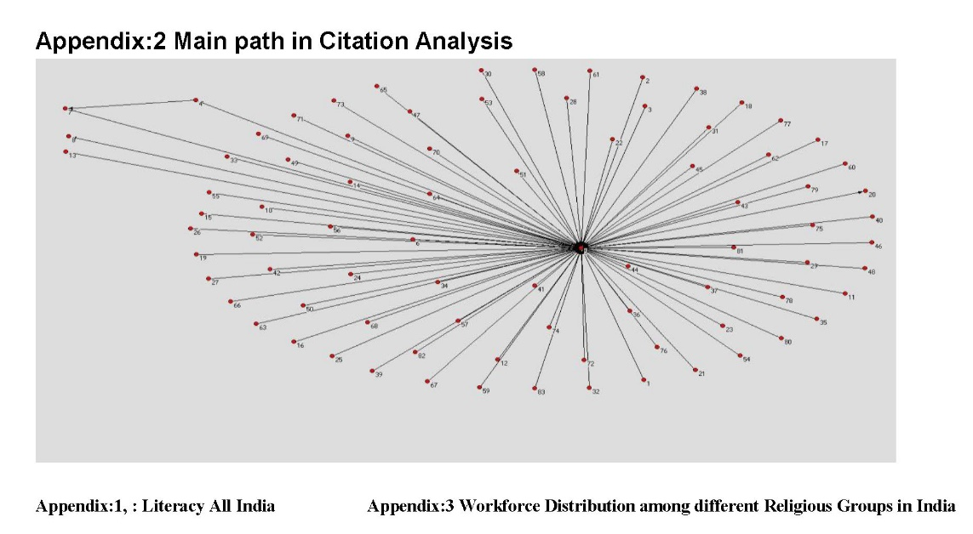
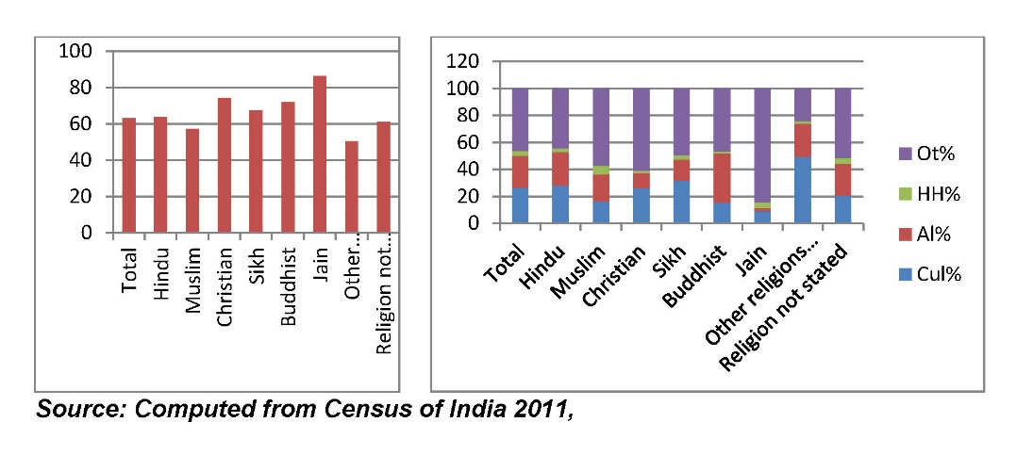
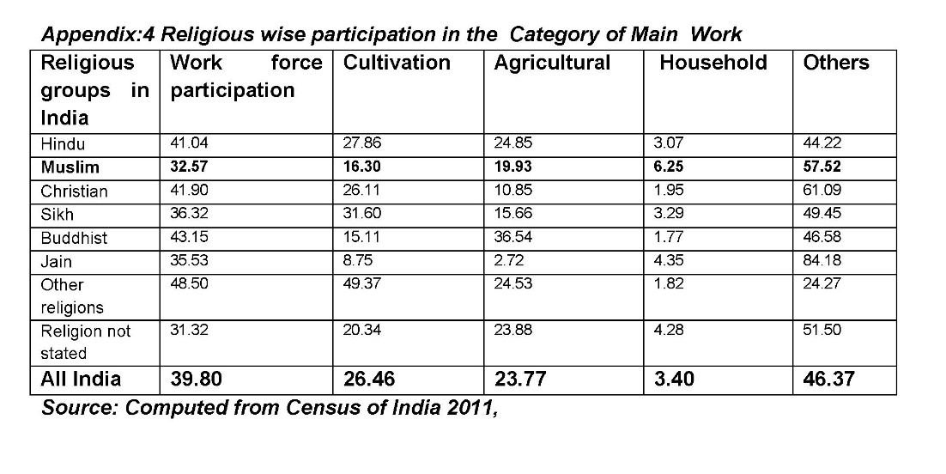

* Assist. Prof. Dr. Department of Sociology, University of Kerala, India, bushrabeegom@gmail.com
The National Sample Survey office(NSSO), earlier known as National Sample Survey Organisation, is an organization under the Ministry of Statistics of the Government of India. It is the largest organisation in India conducting regular socio-economic surveys. It was established in 1950.
55th NSSO Report, Government of India.
68th NSSO Report, Government of India
Milligan, Scott, Anderson, Robert and Robert Brym, 2014, 'Assessing Variation in Tolerance in 23 Muslim-Majority and Western Countries', Canadian Review of Sociology, 51. 3, Canadian Sociological Association
Nancy J.Davis & Robert V Robinson: The egalitarian face of Islamic Orthodoxy: support for Islamic Law and Economic Justice in Seven Muslim Majority Nations; American Sociological Review, Vol.71,No.2 (Apr.2006), pp167-190.
Tharailath Koshy Oommen is an Indian sociologist, author, educationist and Professor Emeritus at the Centre for the Study of Social Systems, Jawaharlal Nehru University . He was awarded Padma Bhushan, the third highest Indian civilian award in 2008 for his services to the fields of education and literature by the President of India.
TK Oommen: Nation, civil Society and Social Movements: Essays in Political Sociology; Sage Publications; New Delhi, 2004.
Editor Note: This definition has not been supported by the author with any reference. However Nursi explains the method of Risale-i Nur as "the positive service of belief which results in the preservation of public order and stability." (Emirdağ Letters, 2016: p.349)
Herbert Marcuse, 2001, 'The Individual int the Great Society', in Douglas Kellner (ed.) Towards a Critical Social Theory: Collected Papers of Herbert Marcuse, Vol. 2, Routledge: London, p. 63.
Riaz Hassan, 2001, 'Imagining Religion: Self-Images of Islam in the Late Twentieth' Century, Asian Studies Review, Vol. 25, No. 2
Badiuzzaman Said Nursi, 2010, 'The Tenth Topic, A Flower of Emirdag', in Shukran Vahide (trans.) The Fruits of Belief, Barla Publication: New Delhi.
Rodney Stark, 1999, 'Micro-Foundations of Religion: A Revised Theory', Sociological Theory, Vol. 17, No. 3, pp. 264 – 289.

